


Laboratory Manual
EE2221: Basic Electronics Lab
Name: ___________________________
Reg_{. No:} ___________________________
Section: ___________________________

Department of Electrical and Computer Engineering
Capital University of Science and Technology

Islamabad, Pakistan

© Copy Rights, Department of Electrical and Computer Engineering, CUST Islamabad
All Rights Reserved
Prepared By: Ahmed Ali
Revised By: Ishmal Khaliq Khan

List of Experiments

- Oscilloscope and Function Generator Operation
- V-I Characteristics of Diode
- Analysis of Series and Parallel Connected Diodes
- Analysis of Half and Full Wave Rectifiers
- Operation of Clipper Circuits
- Operation of Clamper Circuits
- Light Emitting and Zener Diode
- DC Analysis of Bipolar Junction Transistor (BJT)
- Determination of Q-Point for Fixed and Voltage Divider Bias Configuration of a BJT
- Determination of Q-Point for Emitter and Collector Feedback Bias Configuration of BJT
- DC Analysis of Junction Field Effect Transistor (JFET)
- Determination of Q-Point for Fixed, Self and Voltage Divider Bias Configuration of JFET Circuits
- AC Analysis of Common Emitter and Common Base Amplifier
- AC Analysis of Common Source JFET Amplifier

SAFETY RULES AND REGULATIONS
- No laboratory experiment will be performed without laboratory Instructor.
- Before equipment is made live, circuit connections and layout should be checked by the Instructor.
- Never make any changes to circuits without firstly isolating the circuit by switching off and removing connections to supplies.
- Voltages above 50 V_{rms} ac and 50 V dc are always dangerous. Extra precautions should be considered as voltage level is increased.
- Be familiar with the location and operation of safety and emergency equipment such as emergency power off and fire extinguishers in your lab.
- Remove metal bracelets or watchstraps before laboratory experiment.
- Use extension cords only when necessary and only on a temporary basis.
- Do not use damaged cords, cords that become hot or cords with exposed wiring. Inform the instructor about damaged cords.
- Know the correct handling procedures for batteries, cells, capacitors, inductors and other high energy-storage devices.
- Inform your instructor if experiments are left unattended. Such experiments should be kept isolated from the supplies.
- Equipment found to be faulty in any way should be reported immediately and not used until it is inspected and declared safe.

Sign: ________________________________
Name: ________________________________
Registration No: ________________________________ Dated: ________________________________

Experiment no 1
Oscilloscope and Function Generator Operation

OBJECTIVES:

  - To study about Function Generator.
  - To study about Analog Oscilloscope and observe basic waveforms on CRO

EQUIPMENT REQUIRED:

  - Function Generator
  - Probes for Oscilloscope and Function Generator
  - Cathode Ray Oscilloscope

INTRODUCTION:

The world of electronics is a realm of infinite possibilities, where currents and voltages dance to the tune of scientific exploration and technological innovation. At the heart of this intricate dance lies two indispensable tools: the oscilloscope and the function generator. These instruments are the maestros of the electronic symphony, allowing engineers, scientists, and hobbyists to visualize and manipulate electrical signals with precision and finesse.
An oscilloscope, often referred to as an "oscillograph" or simply a "scope," is a device that plays the role of a visual interpreter in the world of electronics. It provides a real-time display of electrical waveforms, enabling users to analyze the behavior of signals with precision. By faithfully rendering voltage over time on its screen, the oscilloscope transforms abstract electrical phenomena into tangible, comprehensible graphs. This graphical representation opens a window into the inner workings of circuits, revealing details that would otherwise remain hidden. Oscilloscopes are essential tools for diagnosing problems, debugging circuits, and verifying the performance of electronic devices.
On the other hand, the function generator is a versatile device that complements the oscilloscope's capabilities. While the oscilloscope observes and records electrical signals, the function generator creates them. Function generators are skilled composers that produce a wide range of waveforms, from simple sine waves to complex, custom-designed signals. These waveforms serve as input signals for circuits and devices under test, allowing engineers to simulate real-world scenarios and study the responses of their creations. Function generators are indispensable for designing, testing, and calibrating electronic circuits and systems.

OSCILLOSCOPE:
An oscilloscope is easily the most useful instrument available for testing circuits because it allows you to see the signals at different points in the circuit. The best way of investigating an electronic system is to monitor signals at the input and output of each system block, checking that each block is operating as expected and is correctly linked to the next. With a little practice, you will be able to find and correct faults quickly and accurately.
The function of an oscilloscope is extremely simple: it draws a V/t graph, a graph of voltage against time, voltage on the vertical or Y-axis, and time on the horizontal or X-axis. The simple graph of Oscilloscope tells us many things about the signal such as:
- The time and voltage values of a signal
- The frequency of an oscillating signal
- The “moving parts” of a circuit represented by the signal
- The frequency with which a particular portion of the signal is occurring relative to other portions
- Whether or not a malfunctioning component is distorting the signal
- How much of a signal is direct current (DC) or alternating current (AC)
- How much of the signal is noise and whether the noise is changing with time
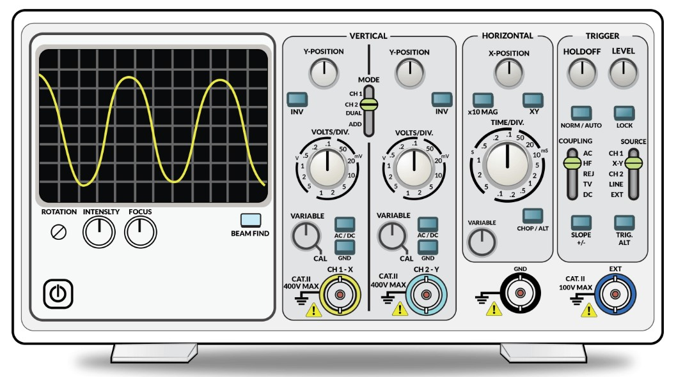

Figure 5: Cathode Ray Oscilloscope Display Group:
This group is used to display and adjust the signal for optimal viewing. It consists of the display screen, the intensity-control knob, the beam-find button, the focus-control knob, and the power switch.
The display screen is laid out in a 8 by 10 centimeter grid. The oscilloscope draws a ‘trace’ or graph by moving an electron beam across the phosphor coating on the inside of the cathoderay tube (CRT). The excited phosphorous glows for a short period of time, thereby tracing the path of the beam.
The intensity-control knob is used to adjust the brightness of the trace. The level should be set to the user's preference; however, increasing the intensity beyond a certain point will make the trace "fuzzy." The intensity level should never be increased past the point where the trace has sharply defined edges.
The beam-find button allows the user to locate the electron beam anytime it's off-screen. Push the beam find button to temporarily reduce the vertical and horizontal deflection voltages so that the beam always appears within the 8 by 10 centimeter screen.
The focus-control knob adjusts the electron beam for optimal trace resolution.
Vertical Group:
This group is used to adjust the vertical components (Y-axis) and the vertical position of the signal. This group consists of the vertical-position knobs, channel-selector switch, voltsper-division selector knobs, input-coupling switch, the channel-mode-selector switch, the channel-2-invert switch, and the BNC connectors. Because the oscilloscope available in the lab is a two channel oscilloscope, there is one set of switches for each channel.
- The vertical-position controls are used to vertically move the trace of one channel or the other.
- The channel-selector switch, labeled ‘CH1/BOTH/CH2’, selects which channels are displayed on the screen.
- The volts-per-division-selector knob sets the vertical scale for each channel's trace.
- Since a 10X probe is used in this lab, all readings should be made from the ‘10X’ box on the knob.
- Each channel can have a different vertical scale.
- A division is one "block" on the screen.
- Each tick mark is one-fifth (0.2) of a division.
- This knob is marked in both volts and millivolts.
- The input-coupling switch, labeled ‘AC/GND/DC’, selects the coupling mode of that channel's display. AC means that only the alternating portion of the signal is displayed. DC will display both the alternating portion of the signal, plus any DC component. GND shows the 0 V reference level.
- The trace-separation knob is used in conjunction with the horizontal-magnification controls, to be discussed later.
- The channel-mode-selector switch, labeled ‘ADD/ALT/CHOP’, is activated only when BOTH is selected on the channel-selector switch. ADD graphically adds the Channel 1 signal to the Channel 2 signal. If the channel-2-invert switch (‘NORMAL/INVERT’) is set to INVERT, then ADD will in fact subtract the Channel 2 signal from the Channel 1 signal. ALT traces one channel, then the next. CHOP works like ALT, but jumps back and forth between the two channels during a single trace.
Horizontal Control Group:
The Horizontal Control Group consists of the coarse and fine position knobs, the horizontal magnification switch, the seconds-per-division-selector knob, and the magnification-scaleselector switch.
- The coarse and fine-position-knobs allow the horizontal movement of the traces in a rough manner and in a precise manner, respectively. These are used to position the traces in a manner that makes measurement both more convenient and more precise.
The horizontal-magnification switch (‘X1/ALT/MAG’) selects the regular (X1) and/or a horizontally magnified trace.
- The trace separation knob in the Vertical-Control Group allows for the vertical separation of the X1 trace from the magnified trace when ALT is selected.
- If ALT or MAG is selected, then the magnification-scale-selector switch (‘5X/10X/50X’) is activated.
The seconds-per-division knob sets the time base (horizontal) scale. It is marked in seconds, milliseconds, and microseconds. Note: There is only one horizontal scale for both channels.
Trigger Group:
In order to display a signal, the oscilloscope must be able to ‘lock’ onto that signal; the function of the triggering controls is to do just that. Triggering can be a complicated topic, and is beyond the scope of this lab. For more details, the student is referred to the Tektronix manual. The trigger group is made up of the trigger level knob, the rising/falling edge switch, the trigger mode switch, the holdoff knob, the trigger source switches, and the trigger coupling switch.
- The trigger-level knob sets the voltage level at which the oscilloscope will ‘trigger’. If a signal is ‘running’ -- that is, not stable -- the trigger level may be too high or too low for the oscilloscope to recognize the signal. Often you can lock in a running signal by rotating this knob to the left and to the right. This adjustment provides a mechanism for ignoring small (low voltage) signals that are well below the level of the signal you ar interested in. This knob is not indexed.
- The rising/falling-edge switch selects whether the oscilloscope will trigger on the positive (rising) or negative (falling) edge of the signal.
- The trigger-mode switch will normally be set to AUTO, but sometimes it is necessary to use NORM. Other settings are not relevant to this lab.
- The holdoff knob affects the delay associated with triggering. The student should consult the manual if more information is desired.
- The trigger-source switches select which signal the oscilloscope will attempt to lock onto. Possible choices include CH1, CH2, VERT MODE, or EXTERNAL. Selecting CH1 or CH2 will make the oscilloscope attempt to trigger on those channels. If no input is available on that channel, there may be problems when attempting to view both channels simultaneously. For this reason, it is recommended that this switch be left on VERT MODE, which provides an automatic trigger on either CH1 or CH2.
- The trigger-coupling switch is another more complicated feature which will not be discussed here. This switch should typically be set to AC
Setting Up / Calibrating an Oscilloscope for Nominal Operation:
First disconnect all input cables to your oscilloscope except the rear power cable.
Control | Settings | Notes
INPUTS | DISCONNECTED
POWER | ON | Led Light is ON
INTENS(ITY) | MID-RANGE
FOCUS | MID-RANGE
Y-POS(ITION) | MID-RANGE | (both knobs: A and B channels)
X-POS(ITION) | MID-RANGE
VAR(IABLE) | CAL | (fully clockwise) All 3 knobs
HOLD OFF | MIN(IMUM) | (fully clockwise)
TRIG(GER) LEVEL | MID-RANGE
LOCK | OFF
Function Generator:
A function generator is a device that can produce various patterns of voltage at a variety of frequencies and amplitudes. Most function generators allow the user to choose the shape of the output from a small number of options.
Square wave - The signal goes directly from high to low voltage.
Sine wave - The signal curves like a sinusoid from high to low voltage. Triangle wave - The signal goes from high to low voltage at a fixed rate.
The amplitude control on a function generator varies the voltage difference between the high and low voltage of the output signal. The direct current (DC) offset control on a function generator varies the average voltage of a signal relative to the ground. The frequency control of a function generator controls the rate at which output signal oscillates.
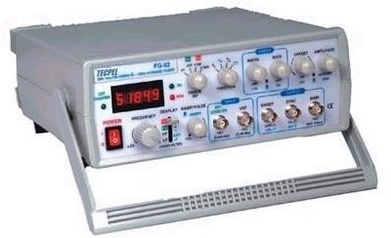

Figure 6: Digital Function Generator

Readings and Exercises:
Task 1:

Calibrate the Cathode Ray Oscilloscope as per the procedure mentioned in the details before. Sketch the Waveform in the Graph given below:

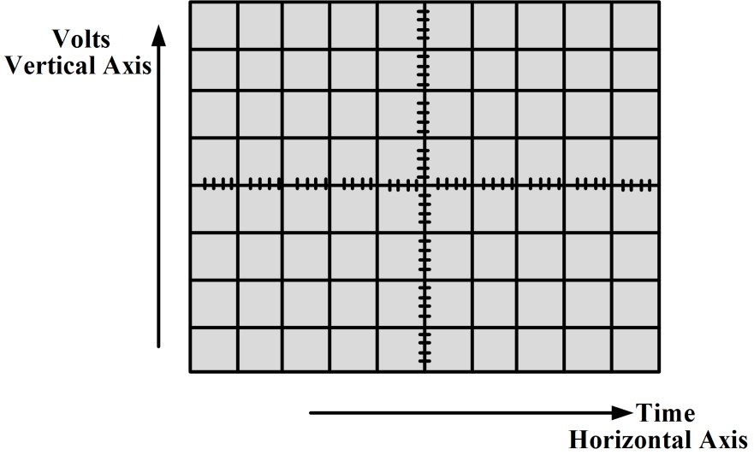
Volts/Div:

_____________

Time/Div.:
______________

Task2:

Construct Sine Wave of 5V_{p-p} and 2 KHz and connect oscilloscope with function generator as per the procedure mentioned in the details before. Sketch the Waveform in the Graph given below:

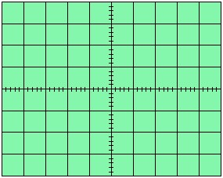
Vm = ____________

V/div = ____________

Div (vertically)= ____________

T/div= ____________

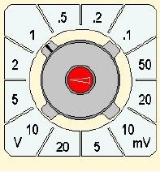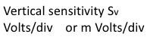Div (Horizontally)=__________

Frequency= ____________

Lab Exercise and Summary
Summary should cover Introduction, Procedure, Data Analysis and Evaluation.

Student’s Signature: ________________ Date: ________________
Cognitive Activity

Q1. The CRO shows one full sine cycle spanning 5 divisions horizontally at 1 ms/div. The waveform is 4 divisions peak-to-peak at 2 V/div. Find Vpp, Vp, Vrms, the time period T and the frequency f. (2)
Ans:

Q2. Mystery of the missing wave: the function generator is ON and connected, but the CRO shows only a flat horizontal line. List three quick checks you would make before calling the instructor. (2)
Ans:

Q3. You connect a +5 V DC battery to CH1 (2 V/div). Describe what the trace does in DC coupling and then in AC coupling. (2)
Ans:

Q4. The function generator is set to a 6 Vpp, 1 kHz sine wave with a +3 V DC offset. What are the maximum and minimum voltages the CRO will show (DC coupled)? (2)
Ans:

Q5. A signal completes 2.5 cycles across the full 10-division screen at 2 ms/div. What is its frequency? Why is a 10X probe preferred for most measurements? (2)
Ans:

Obtained Marks | /10

Psychomotor Activity 1 — Experimental Setup
S. No | Criteria | Performance | Description | Marks
1 | Equipment Setup & Safety (4) | Level 4 | Switches ON and configures the CRO (power ON, intensity/focus, CH1 mode) and the function generator correctly and independently, and completes the pre-power safety check (supply OFF, no loose wires, instructor approval) without reminders. | 4
1 | Equipment Setup & Safety (4) | Level 3 | Configures the equipment with minor errors or assistance and completes most of the safety checks after one reminder. | 3
1 | Equipment Setup & Safety (4) | Level 2 | Completes the setup with considerable assistance; safety checks are partial and need repeated reminders. | 2
1 | Equipment Setup & Safety (4) | Level 1 | Setup is incomplete and requires substantial assistance; safety checks are skipped or done unsafely. | 1
2 | Probe & Signal Connection Setup (4) | Level 4 | Connects the function generator to CH1 using the BNC cable/probe correctly (probe ground to ground, 1X/10X matched) independently. | 4
2 | Probe & Signal Connection Setup (4) | Level 3 | Connections are mostly correct with minor errors (e.g. wrong probe ratio or loose clip) corrected after a hint. | 3
2 | Probe & Signal Connection Setup (4) | Level 2 | Connections are partially correct and need considerable assistance. | 2
2 | Probe & Signal Connection Setup (4) | Level 1 | Major errors (no ground, wrong channel or cable) and substantial assistance needed. | 1
3 | Parameter Setup (2) | Level 2 | Correctly sets the function generator (waveform, frequency, amplitude) and CRO controls (VOLTS/DIV, TIME/DIV, coupling, trigger) before powering the circuit. | 2
3 | Parameter Setup (2) | Level 1 | Sets most of the required parameters with minor errors (e.g. wrong coupling or trigger setting). | 1
Total Obtained |  |  |  | /10
If a student is absent:
Criteria | Description | Marks
Absent | Student is absent from the laboratory activity. | 0
Psychomotor Activity 2 — Implementation + Results
S. No | Criteria | Performance | Description | Marks
1 | Implementation (4) | Level 4 | Carries out the waveform display procedure (sine, square and triangle) on the CRO correctly and independently, following the procedure step by step. | 4
1 | Implementation (4) | Level 3 | Carries out the experiment with minor errors or assistance. | 3
1 | Implementation (4) | Level 2 | Partially carries out the experiment and requires considerable assistance. | 2
1 | Implementation (4) | Level 1 | Implementation is largely incomplete and requires substantial assistance. | 1
2 | Execution/Measurement & Safety (2) | Level 2 | Powers ON only after instructor approval, takes peak-to-peak voltage, time period and frequency readings from the screen correctly and follows all safety rules (isolate before changes, correct polarity) without reminders. | 2
2 | Execution/Measurement & Safety (2) | Level 1 | Takes the measurements with minor errors or assistance and needs reminders to follow the safety rules. | 1
3 | Results/Output (4) | Level 4 | Obtains correct amplitude, period and frequency values for each waveform and presents them clearly with units and labelled axes/sketches. | 4
3 | Results/Output (4) | Level 3 | Obtains mostly correct results with minor errors in readings or presentation. | 3
3 | Results/Output (4) | Level 2 | Obtains partially correct results with noticeable errors or omissions. | 2
3 | Results/Output (4) | Level 1 | Results are largely incorrect or incomplete and require substantial correction. | 1
Total Obtained |  |  |  | /10
If a student is absent:
Criteria | Description | Marks
Absent | Student is absent from the laboratory activity. | 0

Affective Activity — Lab Report + Viva Voce
S. No | Criteria | Performance | Description | Marks
1 | Lab Report Completeness & Organization (4) | Level 4 | Completes and organizes the report systematically (objective, equipment, waveform sketches with VOLTS/DIV and TIME/DIV settings, summary), demonstrating responsibility for the assigned laboratory work. | 4
1 | Lab Report Completeness & Organization (4) | Level 3 | Report is complete with minor omissions or organizational issues. | 3
1 | Lab Report Completeness & Organization (4) | Level 2 | Report is partially complete with several omissions. | 2
1 | Lab Report Completeness & Organization (4) | Level 1 | Report contains major omissions and shows limited responsibility toward the assigned work. | 1
2 | Results, Discussion & Conclusion (2) | Level 2 | Presents the results (amplitude, period and frequency values for each waveform) accurately and provides a clear discussion and conclusion based on the completed laboratory work. | 2
2 | Results, Discussion & Conclusion (2) | Level 1 | Presents the required results with minor errors or limited discussion/conclusion. | 1
3 | Viva Voce (4) | Level 4 | Clearly explains the working of the CRO and function generator controls, the implementation and the results, demonstrating individual responsibility and effective communication. | 4
3 | Viva Voce (4) | Level 3 | Explains most aspects of the assigned work correctly with minor difficulty. | 3
3 | Viva Voce (4) | Level 2 | Explains the basic aspects of the assigned work with some prompting. | 2
3 | Viva Voce (4) | Level 1 | Demonstrates limited involvement or understanding of the assigned work and requires substantial prompting. | 1
Total Obtained |  |  |  | /10
The student has not submitted the report and has not appeared in the Viva Voce.
Criteria | Description | Marks
Lab Report and Results Not Submitted | Student has not submitted the report and results file. | 0
Absent in Viva Voce | Student is absent from the viva voce. | 0

Instructor’s Signature: ________________ Date:________________

Experiment 2

V-I Characteristics of Diode

OBJECTIVES:

- To study and verify the functionality of Diode in forward bias and reverse bias and to plot Volt- Ampere Characteristics of simple Diode.
- To study and verify the functionality of a Transistor to plot Volt-Ampere Characteristics of a Transistor.

Operation:

The P-N junction diode is the most essential and the basic building block of the electronic device. The PN junction diode is a two terminal device, which is formed when one side of the PN junction diode is made with p-type and doped with the N-type material. The PN-junction is the root for semiconductor diodes. There are three possible biasing conditions and two operating regions for the typical PN-Junction Diode, they are: zero bias, forward bias and reverse bias. When no voltage is applied across the PN junction diode then the electrons will diffuse to P-side and holes will diffuse to N-side through the junction and they combine with each other. Therefore, the acceptor atom close to the P-type and donor atom near to the N-side are left unutilized. An electronic field is generated by these charge carriers. This opposes further diffusion of charge carriers. Thus, no movement of the region is known as depletion region or space charge. If we apply forward bias to the PN-junction diode that means negative terminal is connected to the P-type material and the positive terminal is connected to the N-type material across the diode which has the effect of decreasing the width of the PN junction diode. If we apply reverse bias to the PN-junction diode, that means positive terminal is connected to the P-type material and the negative terminal is connected to the N-type material across the diode which has the effect of increasing the width of the PN junction diode and no charge can flow across the junction.

Characteristics of a P-N Junction Diode

It generally shows the relation between bias voltage and current of a diode. The V-I characteristics of a diode can be forward or reverse. The graph showing the forward bias voltage and forward current is known as the forward characteristics, and that showing the reverse bias voltage and reverse current is known as the reverse characteristics.

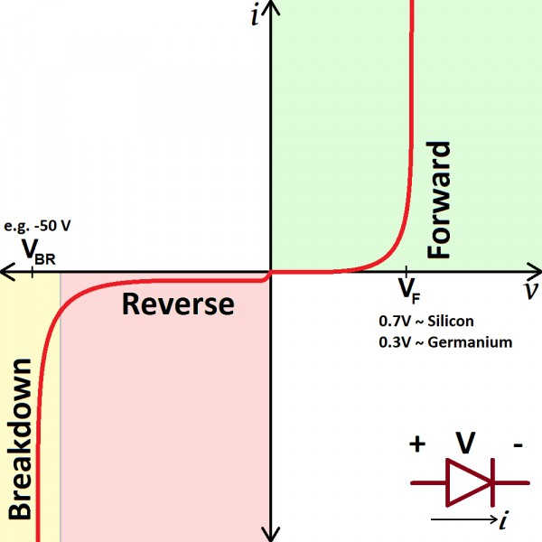

The forward characteristics of a diode is non-linear. The forward current increases slowly in the beginning and shows a sudden rise at a certain value of forward voltage. This voltage is known as the threshold voltage or Knee voltage. This is because the resistance is very low in forward biased condition. The current in the reverse bias is due to the flow of minority carriers. The reverse current shows a sudden increase at a particular region. The corresponding voltage is termed as the reverse breakdown voltage.

Material Required:

- A p-n junction diode
- Variable resistors
- 1-15 V battery
- Voltmeter
- Ammeter
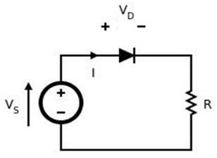
- Connecting Wires

Fig.1 forward biased diode

Procedure
- Forward Bias Condition:

  - Connect the circuit as shown in figure (1).

Initially vary Vs in steps. Once the current starts increasing vary Vs in steps of 1V up to 12V. Note down the corresponding readings of 𝑉_{𝑑} and 𝐼_{𝑑}

Table 1: Forward Bias Condition

Vs(volts) | Forward Voltage across the | Forward Current through the
Vs(volts) | diode 𝑉_{𝑑} (volts) | diode 𝐼_{𝑑} (mA)

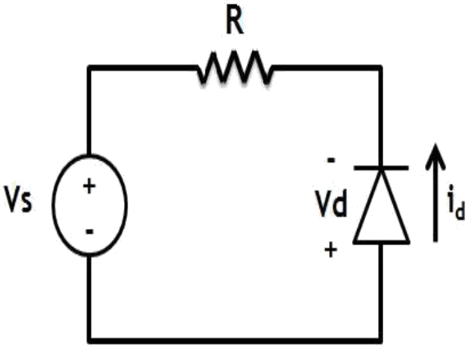

Fig.2 Reverse Bias Diode

- Reverse Bias Condition:

  - Connect the circuit as shown in figure (2).
  - Vary Vs gradually in steps of 1V up to 12V and note down the corresponding readings of 𝑉_{𝑑}
and 𝐼_{𝑑}.
  - Tabulate different reverse currents obtained for different reverse voltages.

Table 2: Reverse Bias Condition

Vs(volts) | Reverse Voltage across the | Reverse Current through the
Vs(volts) | diode 𝑉_{𝑑} (volts) | diode 𝐼_{𝑑} (mA)

- With help of measured values in table 1 and 2 draw V-I characteristics of diode

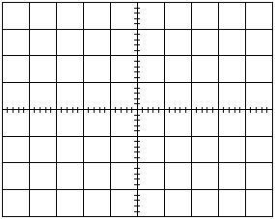
Fig.3 V-I Characteristics of Diode

Lab Exercise and Summary
Summary should cover Introduction, Procedure, Data Analysis and Evaluation.

Student’s Signature: Date:
Cognitive Activity

Q1. While filling Table 1 you notice the current stays almost zero until Vs is about 0.5 V and then shoots up. Why does the diode 'wait', and what is this voltage called? (2)
Ans:

Q2. Vs = 5 V, a 1 kΩ series resistor and a silicon diode (Vd = 0.7 V) are connected in forward bias. Find the diode current Id. (2)
Ans:

Q3. A classmate connects a diode directly across a 5 V supply in forward bias 'to see what happens'. Predict the result and explain why the series resistor in Fig. 1 matters. (2)
Ans:

Q4. In reverse bias your voltmeter reads Vd = Vs, but the ammeter reads almost 0 mA. Where did the voltage go and which carriers make the tiny leakage current? (2)
Ans:

Q5. You warm the diode with your finger while keeping the forward current constant. Does Vd rise or fall, and roughly by how much per degree Celsius? (2)
Ans:

Obtained Marks | /10

Psychomotor Activity 1 — Experimental Setup
S. No | Criteria | Performance | Description | Marks
1 | Equipment Setup & Safety (4) | Level 4 | Switches ON and configures the DC power supply and the digital multimeters (voltage and current modes) correctly and independently, and completes the pre-power safety check (supply OFF, no loose wires, instructor approval) | 4
1 | Equipment Setup & Safety (4) | Level 3 | Configures the equipment with minor errors or assistance and completes most of the safety checks after one reminder. | 3
1 | Equipment Setup & Safety (4) | Level 2 | Completes the setup with considerable assistance; safety checks are partial and need repeated reminders. | 2
1 | Equipment Setup & Safety (4) | Level 1 | Setup is incomplete and requires substantial assistance; safety checks are skipped or done unsafely. | 1
2 | Circuit/Breadboard Setup (4) | Level 4 | Builds the forward and reverse bias circuits as per Figs. 1-2 with correct diode polarity, resistor and meter connections, independently. | 4
2 | Circuit/Breadboard Setup (4) | Level 3 | Circuit is mostly correct with minor errors (e.g. loose lead, one meter placed wrongly) corrected after a hint. | 3
2 | Circuit/Breadboard Setup (4) | Level 2 | Circuit is partially built and needs considerable assistance to match the schematic. | 2
2 | Circuit/Breadboard Setup (4) | Level 1 | Major errors (reversed diode, meter across supply, missing resistor). | 1
3 | Parameter Setup (2) | Level 2 | Correctly sets the supply to 0 V start value, step size (1 V), and DMM ranges for Vd and Id before powering the circuit. | 2
3 | Parameter Setup (2) | Level 1 | Sets most of the required parameters with minor errors (e.g. wrong step size or meter range). | 1
Total Obtained |  |  |  | /10
If a student is absent:
Criteria | Description | Marks
Absent | Student is absent from the laboratory activity. | 0
Psychomotor Activity 2 — Implementation + Results
S. No | Criteria | Performance | Description | Marks
1 | Implementation (4) | Level 4 | Implements the forward-bias and reverse-bias circuits and takes readings step by step correctly and independently. | 4
1 | Implementation (4) | Level 3 | Implements the experiment with minor errors or assistance. | 3
1 | Implementation (4) | Level 2 | Partially implements the experiment and requires considerable assistance. | 2
1 | Implementation (4) | Level 1 | Implementation is largely incomplete and requires substantial assistance. | 1
2 | Execution/ Testing (2) | Level 2 | Powers the circuit safely, varies Vs in steps and handles basic measurement errors appropriately. | 2
2 | Execution/ Testing (2) | Level 1 | Operates the circuit/instruments with minor errors or assistance. | 1
3 | Results/Output (4) | Level 4 | Records accurate Vd and Id readings for both biasing conditions and plots the V-I characteristics with the knee voltage clearly identified. | 4
3 | Results/Output (4) | Level 3 | Obtains mostly correct results with minor errors in output or presentation. | 3
3 | Results/Output (4) | Level 2 | Obtains partially correct results with noticeable errors or omissions. | 2
3 | Results/Output (4) | Level 1 | Results are largely incomplete or require substantial correction. | 1

If a student is absent:
Criteria | Description | Marks
Absent | Student is absent from the laboratory activity. | 0
Affective Activity — Lab Report + Viva Voce
S. No | Criteria | Performance | Description | Marks
1 | Lab Report Completeness & Organization (4) | Level 4 | Completes and organizes the report systematically, demonstrating responsibility for the assigned laboratory work. | 4
1 | Lab Report Completeness & Organization (4) | Level 3 | Report is complete with minor omissions or organizational issues. | 3
1 | Lab Report Completeness & Organization (4) | Level 2 | Report is partially complete with several omissions. | 2
1 | Lab Report Completeness & Organization (4) | Level 1 | Report contains major omissions and shows limited responsibility toward the assigned work. | 1
2 | Results, Discussion & Conclusion (2) | Level 2 | Presents results accurately and provides clear discussion and conclusion based on the completed laboratory work. | 2
2 | Results, Discussion & Conclusion (2) | Level 1 | Presents the required results with minor errors or limited discussion/conclusion. | 1
3 | Viva Voce (4) | Level 4 | Clearly explains the assigned work, implementation and results, demonstrating individual responsibility and effective communication. | 4
3 | Viva Voce (4) | Level 3 | Explains most aspects of the assigned work correctly with minor difficulty. | 3
3 | Viva Voce (4) | Level 2 | Explains the basic aspects of the assigned work with some prompting. | 2
3 | Viva Voce (4) | Level 1 | Demonstrates limited involvement or understanding of the assigned work and requires substantial prompting. | 1
Total Obtained |  |  |  | /10

The student has not submitted the report and has not appeared in the Viva Voce.
Criteria | Description | Marks
Lab Report and Results Not Submitted | Student has not submitted the report and results file. | 0
Absent in Viva Voce | Student is absent from the viva voce. | 0

Instructor’s Signature: ________________ Date:________________

Experiment 3
Analysis of Series and Parallel Connected Diodes
OBJECTIVE:
- To understand about series and parallel combination of diode.
- To understand and implement the basic logic gates operation using diode.

Operation:
Diodes are connected inside the circuit in two configurations. These configurations are:
- Series configuration
- Parallel configuration
Both of the connection patterns are widely used will be discuss below:
Series Configuration:
A series circuit is one that has more than one component but only one path through
which the electricity (electrons) flows. From one end of the cell (battery), the electrons
move along one path with NO branches, through the component, to the other end of the
cell.
In series circuit of diode, if the diode are forward biased the voltage must be greater than
the knee voltage of each diode so that the current flow in that circuit. If the voltage will
be unable to achieve the sum of voltages of diode, then there will be no current in that
circuit. In case of reverse biased of any or both diode no current will flow because we
have to achieve the breakdown voltage of reversed biased diode which is almost greater
than 400
A series circuit is one that has more than one component but only one path through
which the electricity (electrons) flows. From one end of the cell (battery), the electrons
move along one path with NO branches, through the component, to the other end of the
cell.
In series circuit of diode, if the diode are forward biased the voltage must be greater than
the knee voltage of each diode so that the current flow in that circuit. If the voltage will
be unable to achieve the sum of voltages of diode, then there will be no current in that
circuit. In case of reverse biased of any or both diode no current will flow because we
have to achieve the breakdown voltage of reversed biased diode which is almost greater
than 400
A series circuit is one that has more than one component but only one path through
which the electricity (electrons) flows. From one end of the cell (battery), the electrons
move along one path with NO branches, through the component, to the other end of the
cell.
In series circuit of diode, if the diode are forward biased the voltage must be greater than
the knee voltage of each diode so that the current flow in that circuit. If the voltage will
be unable to achieve the sum of voltages of diode, then there will be no current in that
circuit. In case of reverse biased of any or both diode no current will flow because we
have to achieve the breakdown voltage of reversed biased diode which is almost greater
than 400
A series circuit is one that has more than one component but only one path through
which the electricity (electrons) flows. From one end of the cell (battery), the electrons
move along one path with NO branches, through the component, to the other end of the
cell.
In series circuit of diode, if the diode are forward biased the voltage must be greater than
the knee voltage of each diode so that the current flow in that circuit. If the voltage will
be unable to achieve the sum of voltages of diode, then there will be no current in that
circuit. In case of reverse biased of any or both diode no current will flow because we
have to achieve the breakdown voltage of reversed biased diode which is almost greater
than 400
A series circuit is one that has more than one component but only one path through
which the electricity (electrons) flows. From one end of the cell (battery), the electrons
move along one path with NO branches, through the component, to the other end of the
cell.
In series circuit of diode, if the diode are forward biased the voltage must be greater than
the knee voltage of each diode so that the current flow in that circuit. If the voltage will
be unable to achieve the sum of voltages of diode, then there will be no current in that
circuit. In case of reverse biased of any or both diode no current will flow because we
have to achieve the breakdown voltage of reversed biased diode which is almost greater
than 400
A series circuit is one that has more than one component but only one path through
which the electricity (electrons) flows. From one end of the cell (battery), the electrons
move along one path with NO branches, through the component, to the other end of the
cell.
In series circuit of diode, if the diode are forward biased the voltage must be greater than
the knee voltage of each diode so that the current flow in that circuit. If the voltage will
be unable to achieve the sum of voltages of diode, then there will be no current in that
circuit. In case of reverse biased of any or both diode no current will flow because we
have to achieve the breakdown voltage of reversed biased diode which is almost greater
than 400v
Series connection means a side by side connection. When two components are connected in series, they have one common junction. The variation of voltage and current in a series connection is as follows:
- Potential difference across every component is different.
- The current across every component connected in series remains the same.
The same properties also hold true for diodes when they are connected in a series configuration. When connected in series, we observe the following properties to hold true among the diodes:
- Resultant diode’s forward voltage increases.
- Reverse blocking capabilities of diodes are increased in series connection.
Consider two diodes connected in series. The thing to be kept in mind over here is that all the diodes connected in series won’t have the same characteristics as shown in the graph below.

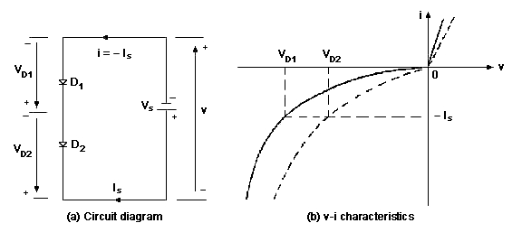
Figure 3.1 Series connected diode configuration
V-I characteristics show that the diodes have different blocking voltages. In forward biased state, the voltage drop and the forward current would be same on the diodes. While in the reverse biased the blocking voltage is different as the diodes have to carry the same leakage current.
This problem can be solved by connected resistances across every diode. Voltage would be shared equally; hence the leakage current would differ.
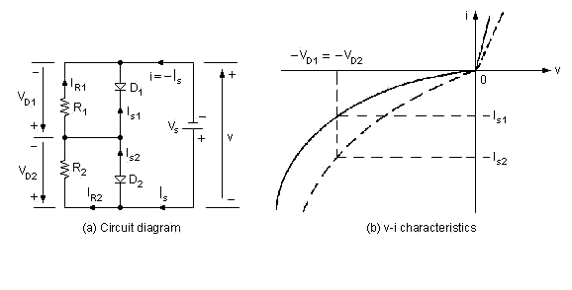
Figure 3.2 Series connected diode with resistor
A single diode cannot meet higher voltage requirements, unless it is connected in series. So the major areas of application are:
- HVDC (High voltage direct current) transmission lines.
- Commercial areas where regulated voltage supply is needed.

Parallel Configuration:
Parallel connection means the components are connected across each other, having two common points. Current differs across each component while voltage drop is same. When diodes are connected in parallel, this same trend is observed.
- Current carrying capacity increases.
- No conduction in resultant diode in both sides.
Consider two diodes connected in parallel configuration. Current would be shared among the two diodes. To make this sharing equal, inductors (with same inductances) are connected. When current at D1 increases, the voltage drop across L1 increases, generating an opposite polarity value at L2. Inductors are used for dynamic conditions. Inductors are usually bulky and expensive and generate spikes which can cause problems.
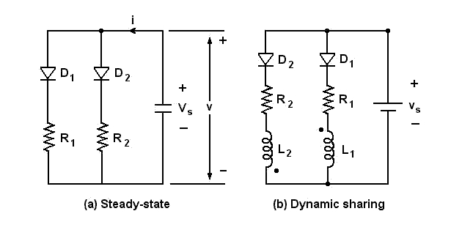
Figure 3.3 Parallel connected connection of diode
Diodes of same type having same voltage drops can be used for steady state conditions. In this case, the parallel diodes would have the same reverse blocking voltages. Some precautions are to be kept in mind while using the diodes with same forward voltage drops, which are:
- The diodes should have same heat sinks.
- They should be cooled equally when necessary.
Negligence would change the temperature of the diodes unequally. This will in turn cause the forward characteristics to differ which can create problems.
Logic Gates: Logic gates are building blocks of the digital system. In this post, we will see how basic digital gates can be made with the help of diodes. If we need an OR gate we can use a 4071 OR CMOS IC or a TTL 7432 OR IC. If we need a AND gate we can use a 4081 AND CMOS IC or a TTL 7408 AND IC but sometimes it is easier to use diodes. Diode Logic uses the fact that diodes conduct only in one direction. (they behave like switches).
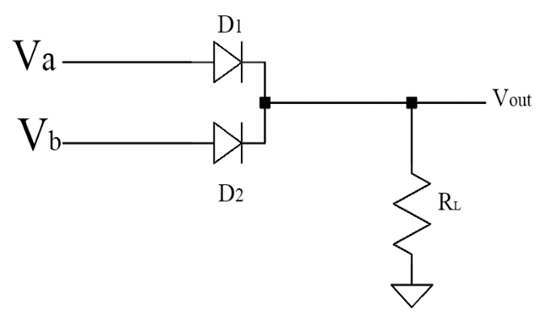
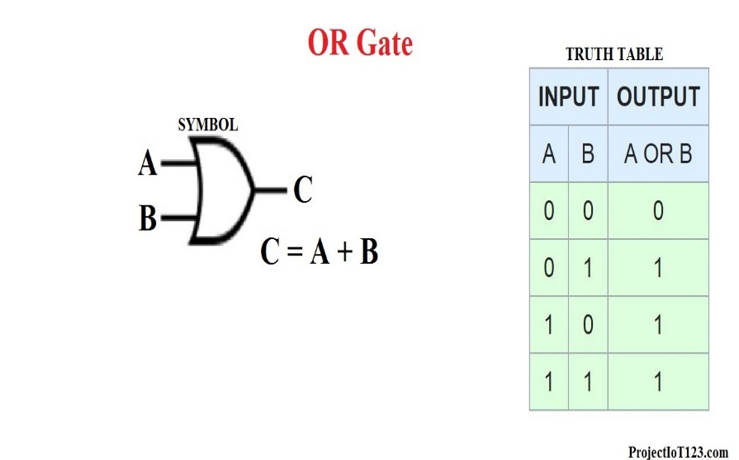
OR Gate Using Diodes:
Figure 3.5: OR Gate Using Diodes
Figure 3.4: OR Gate
OR gate has two or more inputs and only one output. The output of the OR gate is HIGH if one or more inputs are HIGH. Circuit diagram of two input, positive logic OR gate using diodes and a resistor is shown above.
In this logic gate circuit, Va and Vb are inputs and Vout is output. These symbols can take only two values either LOW or HIGH.

Working:
Let us understand the working of this circuit.
- If all inputs are in LOW, both the diode becomes in reverse biased hence acts as an open switch. Hence the output voltage is 0V.
- If A is HIGH and B is LOW, the diode D1 becomes in forward biased hence act as the closed switch. (Neglecting diode forward resistance and voltage drop across the diode) Hence the output is HIGH.
- Also, If A is LOW and B is HIGH. Diode D2 becomes in forward biased and act as an open switch. Hence the output is HIGH.
- If both the input is in HIGH then the output is equal to the more positive value of the input.
Hence OR function has been implemented.
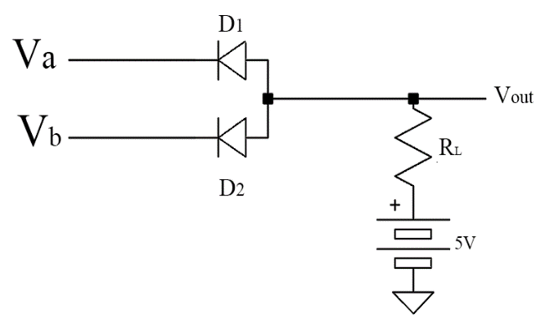
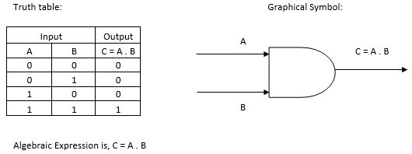
AND
Figure 3.7: AND Gate Using Diodes
Figure 3.6: AND Gate

Gate Using Diodes:
AND gate has two or more inputs and only one output. The output of logic AND gate is HIGH if all inputs are HIGH. For other input, the output is LOW. Circuit diagram of two-input OR gate using diodes and a resistor is shown below:
Here Va and Vb are inputs and Vout is output.
Working:
- If A is HIGN and b is LOW, the diode D1 becomes in reversed biased hence act as an open switch. Also, diode D2 becomes in forward biased hence act as the closed switch. Hence the output is LOW.
- If A is LOW and B is HIGH, the diode D1 becomes in forward biased hence act as the closed switch. Also, diode D2 becomes in reversed biased hence act as an open switch. The output is LOW.
- If all inputs are 0 then all diode becomes in forward biased and act as an open switch. Hence the output is LOW.
- When all inputs are HIGH then all diodes become in the reversed biased hence act as an open switch. Hence the output is HIGH.
Verification of Other Logic Gates
NOT Gate:
When input variable A is low the output of a NOT gate is High. The logic symbol of NOT Gate is shown in Figure 6.5. The IC 74LS04 is a single input NOT Gate IC and it consists of 6NOT gates. The IC has 14 pins constructed in Dual in Line package (DIP) as shown in Figure 6.5. The truth table of NOT Gate is as shown in Figure 3.7.

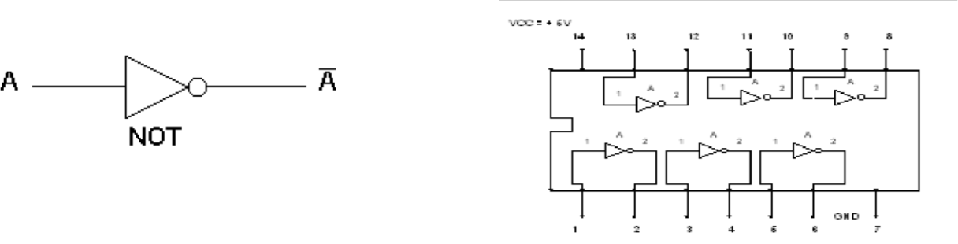

Figure 3.8: NOT - Gate Symbol
NAND Gate:
The outputs of all NAND gates are high if any of the inputs are low. The logic symbol of NAND Gate is shown in Figure 3.9. The IC 74 LS00 is a two input NAND Gate IC. It consists 4 NAND gates built in.
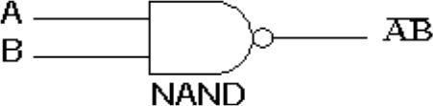

Figure 3.9: NAND Gate

NOR Gate:
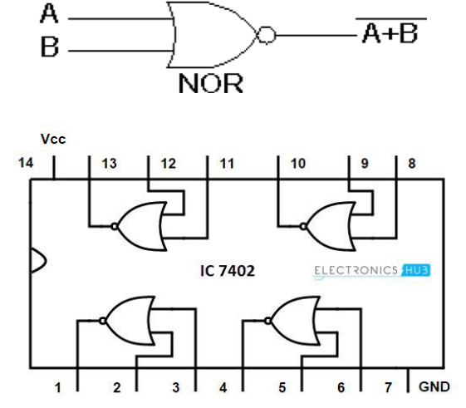
The outputs of all NOR gates are low if any of the inputs are high. The logic symbol of NOR Gate is shown in Fig. The IC 74 LS02 is two in-put NOR Gate IC it consists of 4 NOR gates.

Figure 3.10: NOR Gate
EX-OR Gate:
The 'Exclusive-OR' gate is a circuit which will give a high output if either, but not both, of its two inputs are high. . The logic symbol of EXOR Gate is shown in Figure 3.11. The IC 74LS86 is a single input EXOR Gate IC and it consists of 4- EXOR gates.
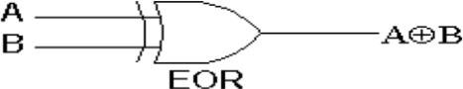
Figure 3.11: EX-OR Gate

EX-NOR Gate:
The 'Exclusive-NOR' gate is a circuit which will give a high output if either, but not both, of its two inputs are high. . The logic symbol of EXNOR Gate is shown in Figure 3.12. The truth table of EXOR.
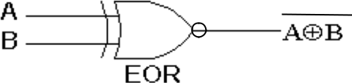


Figure 3.12: EX-NOR Gate

Lab Activities:
- Implement the following circuit on breadboard and find Voltage and current across diodes
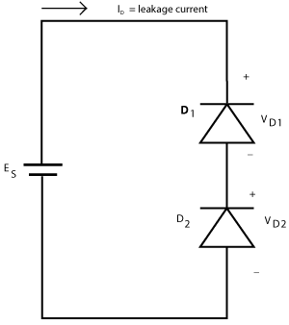
Figure 3.13 Series connected diode
ID = ________________________

VD1 = ______________________

VD2 = ______________________

- Implement the following circuit on breadboard and verify Voltage V1 and find current across diodes
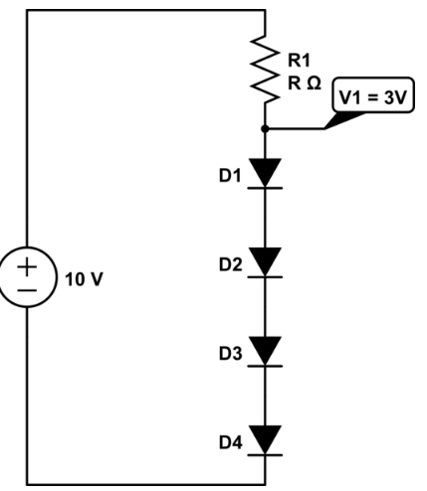

- Implement the following circuit on breadboard and find Voltage and current across diodes
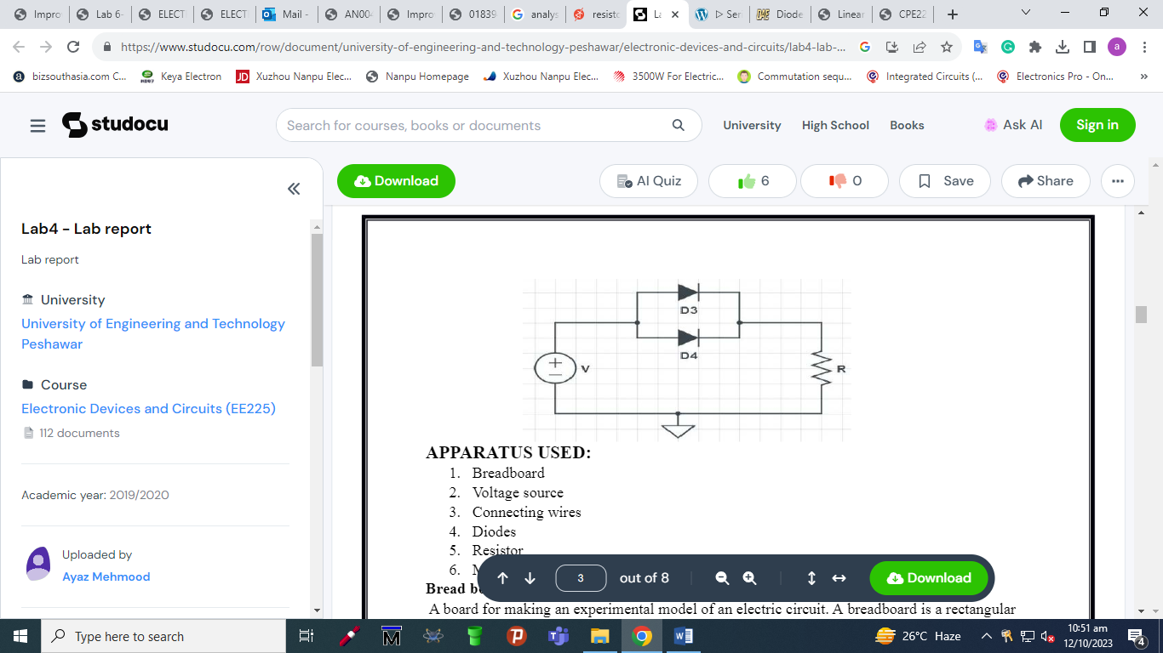

- Implement the following circuit on breadboard also verify their truth table.

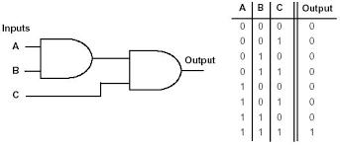

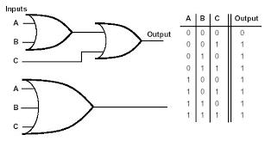

Lab Exercise and Summary
Summary should cover Introduction, Procedure, Data Analysis and Evaluation.

Student’s Signature: ________________ Date: ________________
Cognitive Activity

Q1. Two silicon diodes are connected in series (both forward biased) with a 1 kΩ resistor across a 5 V supply. Find the circuit current. (2)
Ans:

Q2. Now one of the two series diodes is flipped around (5 V supply, 1 kΩ resistor). What is the current, and how is the 5 V shared between the diodes and the resistor? (2)
Ans:

Q3. 'Two 1 A diodes in parallel must give me a 2 A diode.' Why is this dangerous without extra care? (2)
Ans:

Q4. In the diode OR gate, input A = 5 V and input B = 0 V (silicon diodes). What is the output voltage? Why is it not exactly 5 V? (2)
Ans:

Q5. In the diode AND gate (Vcc = 5 V through a resistor), what is the output when A = 0 V and B = 5 V, and when A = B = 5 V? Which diode 'pulls the output down'? (2)
Ans:

Obtained Marks | /10

Psychomotor Activity 1 — Experimental Setup

S. No | Criteria | Performance | Description | Marks
1 | Equipment Setup & Safety (4) | Level 4 | Switches ON and configures the DC power supply, DMM and breadboard (supply OFF, current limit set) correctly and independently, and completes the pre-power safety check (supply OFF, no loose wires, instructor approval) without reminders. | 4
1 | Equipment Setup & Safety (4) | Level 3 | Configures the equipment with minor errors or assistance and completes most of the safety checks after one reminder. | 3
1 | Equipment Setup & Safety (4) | Level 2 | Completes the setup with considerable assistance; safety checks are partial and need repeated reminders. | 2
1 | Equipment Setup & Safety (4) | Level 1 | Setup is incomplete and requires substantial assistance; safety checks are skipped or done unsafely. | 1
2 | Circuit/Breadboard Setup (4) | Level 4 | Builds the series, parallel and diode logic gate (AND/OR) circuits as per the schematics with correct diode orientation and neat wiring, independently. | 4
2 | Circuit/Breadboard Setup (4) | Level 3 | Circuits are mostly correct with minor errors (e.g. one diode reversed or loose lead) corrected after a hint. | 3
2 | Circuit/Breadboard Setup (4) | Level 2 | Circuits are partially built and need considerable assistance. | 2
2 | Circuit/Breadboard Setup (4) | Level 1 | Major errors or omissions in the circuits and substantial assistance needed. | 1
3 | Parameter Setup (2) | Level 2 | Correctly sets the supply/logic input levels (0 V and 5 V), resistor values and DMM range before powering the circuit. | 2
3 | Parameter Setup (2) | Level 1 | Sets most of the required parameters with minor errors (e.g. wrong logic level or meter range). | 1
Total Obtained |  |  |  | /10

If a student is absent:
Criteria | Description | Marks
Absent | Student is absent from the laboratory activity. | 0
Psychomotor Activity 2 — Implementation + Results
S. No | Criteria | Performance | Description | Marks
1 | Implementation (4) | Level 4 | Carries out the series, parallel and diode logic gate circuits and their input combinations correctly and independently, following the procedure step by step. | 4
1 | Implementation (4) | Level 3 | Carries out the experiment with minor errors or assistance. | 3
1 | Implementation (4) | Level 2 | Partially carries out the experiment and requires considerable assistance. | 2
1 | Implementation (4) | Level 1 | Implementation is largely incomplete and requires substantial assistance. | 1
2 | Execution/Measurement & Safety (2) | Level 2 | Powers ON only after instructor approval, takes voltages across each diode and the output voltage for every input combination correctly and follows all safety rules (isolate before changes, correct polarity) without reminders. | 2
2 | Execution/Measurement & Safety (2) | Level 1 | Takes the measurements with minor errors or assistance and needs reminders to follow the safety rules. | 1
3 | Results/Output (4) | Level 4 | Obtains correct voltage/current values and the truth tables of the AND/OR gates and presents them clearly with units and labelled axes/sketches. | 4
3 | Results/Output (4) | Level 3 | Obtains mostly correct results with minor errors in readings or presentation. | 3
3 | Results/Output (4) | Level 2 | Obtains partially correct results with noticeable errors or omissions. | 2
3 | Results/Output (4) | Level 1 | Results are largely incorrect or incomplete and require substantial correction. | 1
Total Obtained |  |  |  | /10
If a student is absent:
Criteria | Description | Marks
Absent | Student is absent from the laboratory activity. | 0
Affective Activity — Lab Report + Viva Voce
S. No | Criteria | Performance | Description | Marks
1 | Lab Report Completeness & Organization (4) | Level 4 | Completes and organizes the report systematically (objective, equipment, circuit diagrams, observation tables and truth tables, summary), demonstrating responsibility for the assigned laboratory work. | 4
1 | Lab Report Completeness & Organization (4) | Level 3 | Report is complete with minor omissions or organizational issues. | 3
1 | Lab Report Completeness & Organization (4) | Level 2 | Report is partially complete with several omissions. | 2
1 | Lab Report Completeness & Organization (4) | Level 1 | Report contains major omissions and shows limited responsibility toward the assigned work. | 1
2 | Results, Discussion & Conclusion (2) | Level 2 | Presents the results (voltage/current values and the truth tables of the AND/OR gates) accurately and provides a clear discussion and conclusion based on the completed laboratory work. | 2
2 | Results, Discussion & Conclusion (2) | Level 1 | Presents the required results with minor errors or limited discussion/conclusion. | 1
3 | Viva Voce (4) | Level 4 | Clearly explains how diodes behave in series/parallel and how they form logic gates, the implementation and the results, demonstrating individual responsibility and effective communication. | 4
3 | Viva Voce (4) | Level 3 | Explains most aspects of the assigned work correctly with minor difficulty. | 3
3 | Viva Voce (4) | Level 2 | Explains the basic aspects of the assigned work with some prompting. | 2
3 | Viva Voce (4) | Level 1 | Demonstrates limited involvement or understanding of the assigned work and requires substantial prompting. | 1
Total Obtained |  |  |  | /10
The student has not submitted the report and has not appeared in the Viva Voce.
Criteria | Description | Marks
Lab Report and Results Not Submitted | Student has not submitted the report and results file. | 0
Absent in Viva Voce | Student is absent from the viva voce. | 0

Instructor’s Signature: ________________ Date: ________________
Experiment 4
Analysis of Half-Wave & Full-Wave Rectification
Objective:
To implement the half wave rectifier and full wave rectifier using 1N 4007 diode
Components Required:
4 Diodes
1 Resistors
Oscilloscope, Multimeter, Function generator
Circuit Diagram
Half Wave Rectifier
Figure 4.1: Half Wave Rectifier
Full Wave Bridge Rectifier
Figure 4.2: Full Wave Rectifier
THEORY:
A diode is using to pass current in a single direction. Alternating current is a current which flows in both directions. In some applications we need dc power supply. A method to obtain dc supply is by using batteries. But it is not economical at all times. It is possible to obtain dc from ac supply .That process is known as rectification. Rectification is of two types: 1.half wave rectification 2.full wave rectification
HALF WAVE RECTIFIERS:
In a half wave rectifier only one half cycle of ac voltage is taking. The circuit is given. Here only one diode is using. During the positive half cycle of ac voltage the diode conducts so current flows through load. During the negative half cycle, the diode is reverse biased .So no current flows through the diode. This type of rectification needs only one diode. But the efficiency is not as good as that of full wave rectifier
FULL WAVE RECTIFIERS:
Unlike a half wave rectifier, a full wave rectifier conducts in both half cycles of ac voltage.
FULL WAVE BRIDGE RECTIFIER:
In full wave bridge rectifiers 4 diodes are using. During positive half cycle, D1 and D4 are in forward biased condition. In the negative half cycle of ac D3 and D2 are in forward biased condition. So in both the half cycles current through the load is in single direction. Thus
rectification can be done. This circuit does not need a center tap rectifier. But it requires more number of diodes than center tap and half wave rectifiers.
PROCEDURE:
- Construct the circuit of Fig.4.3 using the chosen diode of Part Record the measured value of the resistance R. set the function generator to 1000 Hz, 8 Vp-p sinusoidal voltages using the oscilloscope.
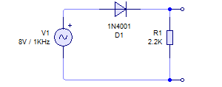
Figure 4.3: Half Wave Rectifier Circuit

Using the oscilloscope with the DC position, obtain the voltage V_{O} and sketch the waveform on Figure 4.4. Before viewing V_{O} be sure to set the V_{O}= 0 V line using the GND position of the coupling switch.
Figure 4.4: Half Wave Rectifier Output
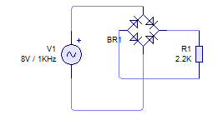
- Construct the full-wave bridge rectifier of Figure 4.5. Be sure that the diodes are inserted correctly and that the grounding is as shown.
Figure 4.5: Half Wave Rectifier Circuit

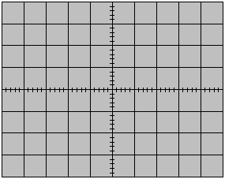
Using the oscilloscope with the DC position, obtain the voltage V_{O} and sketch the waveform on Figure 4.6. Before viewing V_{O} be sure to set the V_{O}= 0 V line using the GND position of the coupling switch.
Figure 4.6: Full Wave Rectifier Output

Lab Exercise and Summary
Summary should cover Introduction, Procedure, Data Analysis and Evaluation.

Student’s Signature: ________________ Date: ________________
Cognitive Activity

Q1. A 10 V peak sine wave feeds a half-wave rectifier with a 1N4007 (0.7 V drop). Find the peak output voltage and the average (DC) output voltage. (2)
Ans:

Q2. The same 10 V peak input now feeds a bridge rectifier. Find the peak output and DC output. Why is the peak lower than in Q1? (2)
Ans:

Q3. The input is 50 Hz. What is the ripple frequency at the output of (a) the half-wave and (b) the full-wave rectifier? (2)
Ans:

Q4. Your bridge rectifier output on the CRO looks like a half-wave signal. Name a likely fault. (2)
Ans:

Q5. Plot twist: when you clip the CRO ground across the load of the bridge rectifier, the output vanishes or a diode gets hot. Why does this happen? (2)
Ans:

Y

Obtained Marks | /10

Psychomotor Activity 1 — Experimental Setup

S. No | Criteria | Performance | Description | Marks
1 | Equipment Setup & Safety (4) | Level 4 | Switches ON and configures the function generator (1 kHz, 8 Vp-p sine), CRO and DMM correctly and independently, and completes the pre-power safety check (supply OFF, no loose wires, instructor approval) without reminders. | 4
1 | Equipment Setup & Safety (4) | Level 3 | Configures the equipment with minor errors or assistance and completes most of the safety checks after one reminder. | 3
1 | Equipment Setup & Safety (4) | Level 2 | Completes the setup with considerable assistance; safety checks are partial and need repeated reminders. | 2
1 | Equipment Setup & Safety (4) | Level 1 | Setup is incomplete and requires substantial assistance; safety checks are skipped or done unsafely. | 1
2 | Circuit/Breadboard Setup (4) | Level 4 | Builds the half-wave and full-wave bridge rectifiers as per Figs. 4.3 and 4.5 with correct diode orientation, load resistor and CRO ground position, independently. | 4
2 | Circuit/Breadboard Setup (4) | Level 3 | Circuits are mostly correct with minor errors (e.g. one diode reversed or wrong ground point) corrected after a hint. | 3
2 | Circuit/Breadboard Setup (4) | Level 2 | Circuits are partially built and need considerable assistance. | 2
2 | Circuit/Breadboard Setup (4) | Level 1 | Major errors (bridge miswired, shorted diode, no ground) and substantial assistance needed. | 1
3 | Parameter Setup (2) | Level 2 | Correctly sets the input signal (1 kHz, 8 Vp-p), VOLTS/DIV, TIME/DIV, DC coupling and the 0 V (GND) reference line before powering the circuit. | 2
3 | Parameter Setup (2) | Level 1 | Sets most of the required parameters with minor errors (e.g. wrong coupling or reference line). | 1
Total Obtained |  |  |  | /10
If a student is absent:
Criteria | Description | Marks
Absent | Student is absent from the laboratory activity. | 0

Psychomotor Activity 2 — Implementation + Results

S. No | Criteria | Performance | Description | Marks
1 | Implementation (4) | Level 4 | Carries out the half-wave and full-wave bridge rectifier measurements correctly and independently, following the procedure step by step. | 4
1 | Implementation (4) | Level 3 | Carries out the experiment with minor errors or assistance. | 3
1 | Implementation (4) | Level 2 | Partially carries out the experiment and requires considerable assistance. | 2
1 | Implementation (4) | Level 1 | Implementation is largely incomplete and requires substantial assistance. | 1
2 | Execution/Measurement & Safety (2) | Level 2 | Powers ON only after instructor approval, takes input and output waveforms on the CRO and the DC output voltage on the DMM correctly and follows all safety rules (isolate before changes, correct polarity) without reminders. | 2
2 | Execution/Measurement & Safety (2) | Level 1 | Takes the measurements with minor errors or assistance and needs reminders to follow the safety rules. | 1
3 | Results/Output (4) | Level 4 | Obtains correct output waveforms sketched with correct peak values, the DC level and the ripple frequency and presents them clearly with units and labelled axes/sketches. | 4
3 | Results/Output (4) | Level 3 | Obtains mostly correct results with minor errors in readings or presentation. | 3
3 | Results/Output (4) | Level 2 | Obtains partially correct results with noticeable errors or omissions. | 2
3 | Results/Output (4) | Level 1 | Results are largely incorrect or incomplete and require substantial correction. | 1
Total Obtained |  |  |  | /10
If a student is absent:
Criteria | Description | Marks
Absent | Student is absent from the laboratory activity. | 0
Affective Activity — Lab Report + Viva Voce
S. No | Criteria | Performance | Description | Marks
1 | Lab Report Completeness & Organization (4) | Level 4 | Completes and organizes the report systematically (objective, equipment, circuit diagrams, input/output waveform sketches and calculations, summary), demonstrating responsibility for the assigned laboratory work. | 4
1 | Lab Report Completeness & Organization (4) | Level 3 | Report is complete with minor omissions or organizational issues. | 3
1 | Lab Report Completeness & Organization (4) | Level 2 | Report is partially complete with several omissions. | 2
1 | Lab Report Completeness & Organization (4) | Level 1 | Report contains major omissions and shows limited responsibility toward the assigned work. | 1
2 | Results, Discussion & Conclusion (2) | Level 2 | Presents the results (output waveforms sketched with correct peak values, the DC level and the ripple frequency) accurately and provides a clear discussion and conclusion based on the completed laboratory work. | 2
2 | Results, Discussion & Conclusion (2) | Level 1 | Presents the required results with minor errors or limited discussion/conclusion. | 1
3 | Viva Voce (4) | Level 4 | Clearly explains the working of half-wave and bridge rectifiers and the observed waveforms, the implementation and the results, demonstrating individual responsibility and effective communication. | 4
3 | Viva Voce (4) | Level 3 | Explains most aspects of the assigned work correctly with minor difficulty. | 3
3 | Viva Voce (4) | Level 2 | Explains the basic aspects of the assigned work with some prompting. | 2
3 | Viva Voce (4) | Level 1 | Demonstrates limited involvement or understanding of the assigned work and requires substantial prompting. | 1
Total Obtained |  |  |  | /10
The student has not submitted the report and has not appeared in the Viva Voce.
Criteria | Description | Marks
Lab Report and Results Not Submitted | Student has not submitted the report and results file. | 0
Absent in Viva Voce | Student is absent from the viva voce. | 0

Instructor’s Signature: ________________ Date: ________________

EXPERIMENT 5

OBJECTIVES

Operation of Clipper Circuits

- To understand the basic application of diode like clipper
- To understand the basic circuit of clamper and implement their practical implementation

THEORY
- Introduction
A semiconductor diode is a non-linear device, which behaves as a small resistance in its forward direction and acts as a large resistance in its reverse direction. This is displayed in the Volt- Ampere (V-I) characteristic which is a graph of current vs. voltage for a diode. By linearizing the V-I characteristic, a diode circuit model is obtained known as a piecewise linear model.

- Diode clipper circuits
A clipper is a circuit in which the output of an input sinusoidal (or any time-dependent signal) waveform can be clipped at different levels. A clipping circuit requires at least two fundamental components, a diode and a resistor. A DC battery, however, is also frequently used. The output waveform can be clipped at different levels simply by interchanging the position of the various elements and changing the magnitude of the DC battery. Generally, ideal diodes are considered and the complete analysis can be based on non-ideal diodes with specific V-I characteristic.
For networks of this type, it is often helpful to consider particular instants of the time-varying input signal to determine the state of the diode (ON or OFF). Keep in mind that even the though input varies, at a specific time instant this time varying signal can be replaced by a DC source of the same value. Figure 1 shows examples of various clipping circuits. Please note that the input to all circuits is a sinusoidal waveform.

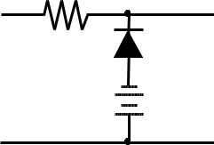
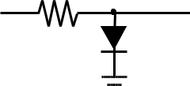
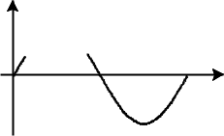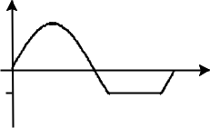V V
out
t
out
t
+ | R | +
V | R | V
in | V | out
- | V | -

+ | R | +
V | R | V
in | V | out
- | V | -

V


V

V
V
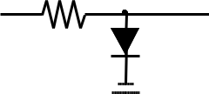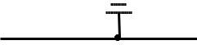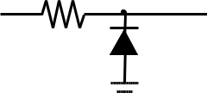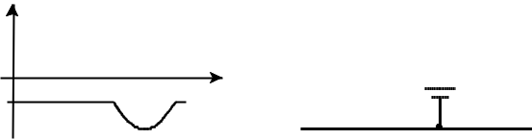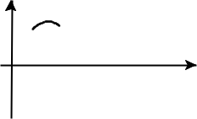out
out
t
+
V
in
-
R
V
+
V
out
-
t
+ | R | +
V | R | V
in | V | out
- | V | -

V
V

Figure 1: Clipping circuits

For two circuits on the left, the maximum output voltage is clipped at Vout = V. (Ideal diode) For two circuits on the right the minimum output voltage is clipped at Vout= V. (Ideal diode) For a non-ideal diode, maximum or minimum output voltage is Vout = V + Vd, or –V
- Vd where Vd is the voltage drop across the diode.

EXPERIMENTAL PROCEDURE
  - Construct the clipping network. Record the measured resistance value and voltage of the D cell. Note that the input is an 8 Vp p Square wave at a frequency of 1000 Hz.
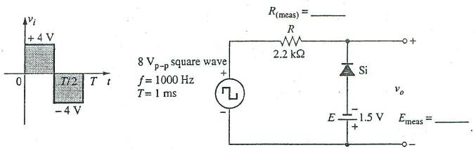

  - Using the measured values of R, E and V_{T} calculate the voltage V_{O} when the applied square wave is +4V, that is, for the interval when the input is +4V. what is the level of V_{O} ? Show all the steps of yours calculations to determine V_{O}

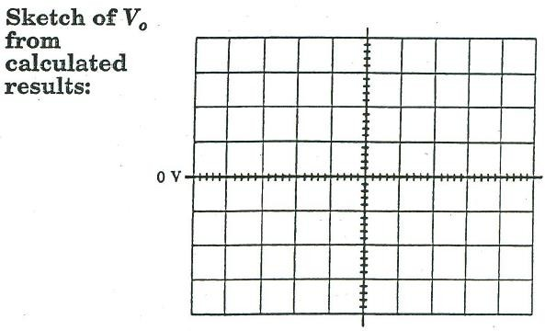

  - Using the sensitivities set the input square wave and record V_{O} using oscilloscope. Be sure to preset the V_{O} = 0 V line using ground position of the coupling switch and the DC position to view the waveform.

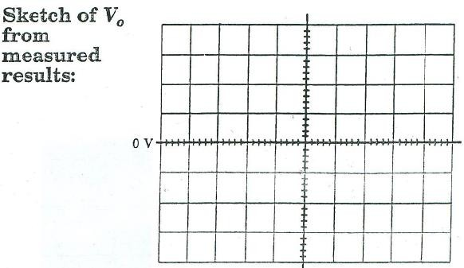

Lab Exercise and Summary
Summary should cover Introduction, Procedure, Data Analysis and Evaluation.

\

Student’s Signature: Date: _

Cognitive Activity

Q1. A shunt clipper has a silicon diode in series with a 3 V battery across the output (diode anode toward the output, battery positive toward the diode cathode). The input is a 10 V peak sine. At what level is the positive peak clipped? (2)
Ans:

Q2. Why must a resistor R be placed in series between the source and the clipping diode? (2)
Ans:

Q3. The lab input is an 8 Vpp square wave (±4 V) and the reference is a 1.5 V D-cell, with the same arrangement as Q1. Predict the maximum and minimum of Vo. (2)
Ans:

Q4. Remove the battery and reverse the diode in Q1's circuit. At what level is the output now clipped, and which half-cycle is affected? (2)
Ans:

Q5. Name one real-life use of a clipper circuit and say what it protects or cleans up. (2)
Ans:

Obtained Marks | /10

Psychomotor Activity 1 — Experimental Setup

S. No | Criteria | Performance | Description | Marks
1 | Equipment Setup & Safety (4) | Level 4 | Switches ON and configures the function generator (1 kHz square wave, 8 Vp-p), CRO, DMM and DC source/D-cell correctly and independently, and completes the pre-power safety check (supply OFF, no loose wires, instructor approval) without reminders. | 4
1 | Equipment Setup & Safety (4) | Level 3 | Configures the equipment with minor errors or assistance and completes most of the safety checks after one reminder. | 3
1 | Equipment Setup & Safety (4) | Level 2 | Completes the setup with considerable assistance; safety checks are partial and need repeated reminders. | 2
1 | Equipment Setup & Safety (4) | Level 1 | Setup is incomplete and requires substantial assistance; safety checks are skipped or done unsafely. | 1
2 | Circuit/Breadboard Setup (4) | Level 4 | Builds the clipping network as per the schematic with correct diode direction, battery polarity and resistor value, independently. | 4
2 | Circuit/Breadboard Setup (4) | Level 3 | Circuit is mostly correct with minor errors (e.g. battery polarity or loose lead) corrected after a hint. | 3
2 | Circuit/Breadboard Setup (4) | Level 2 | Circuit is partially built and needs considerable assistance. | 2
2 | Circuit/Breadboard Setup (4) | Level 1 | Major errors (diode or battery reversed, missing resistor) and substantial assistance needed. | 1
3 | Parameter Setup (2) | Level 2 | Correctly sets the input square wave (8 Vp-p, 1 kHz), CRO sensitivities, DC coupling and the measured R and battery voltage before powering the circuit. | 2
3 | Parameter Setup (2) | Level 1 | Sets most of the required parameters with minor errors (e.g. wrong amplitude or coupling). | 1
Total Obtained |  |  |  | /10
If a student is absent:
Criteria | Description | Marks
Absent | Student is absent from the laboratory activity. | 0

Psychomotor Activity 2 — Implementation + Results
S. No | Criteria | Performance | Description | Marks
1 | Implementation (4) | Level 4 | Carries out the clipping network tests for the given input levels and reference voltages correctly and independently, following the procedure step by step. | 4
1 | Implementation (4) | Level 3 | Carries out the experiment with minor errors or assistance. | 3
1 | Implementation (4) | Level 2 | Partially carries out the experiment and requires considerable assistance. | 2
1 | Implementation (4) | Level 1 | Implementation is largely incomplete and requires substantial assistance. | 1
2 | Execution/Measurement & Safety (2) | Level 2 | Powers ON only after instructor approval, takes the measured R, battery voltage and the clipped output level Vo correctly and follows all safety rules (isolate before changes, correct polarity) without reminders. | 2
2 | Execution/Measurement & Safety (2) | Level 1 | Takes the measurements with minor errors or assistance and needs reminders to follow the safety rules. | 1
3 | Results/Output (4) | Level 4 | Obtains correct the clipped output waveforms with correct clipping levels and matching calculated values and presents them clearly with units and labelled axes/sketches. | 4
3 | Results/Output (4) | Level 3 | Obtains mostly correct results with minor errors in readings or presentation. | 3
3 | Results/Output (4) | Level 2 | Obtains partially correct results with noticeable errors or omissions. | 2
3 | Results/Output (4) | Level 1 | Results are largely incorrect or incomplete and require substantial correction. | 1
Total Obtained |  |  |  | /10
If a student is absent:
Criteria | Description | Marks
Absent | Student is absent from the laboratory activity. | 0

Affective Activity — Lab Report + Viva Voce
S. No | Criteria | Performance | Description | Marks
1 | Lab Report Completeness & Organization (4) | Level 4 | Completes and organizes the report systematically (objective, equipment, circuit diagrams, calculations of Vo and input/output waveforms, summary), demonstrating responsibility for the assigned laboratory work. | 4
1 | Lab Report Completeness & Organization (4) | Level 3 | Report is complete with minor omissions or organizational issues. | 3
1 | Lab Report Completeness & Organization (4) | Level 2 | Report is partially complete with several omissions. | 2
1 | Lab Report Completeness & Organization (4) | Level 1 | Report contains major omissions and shows limited responsibility toward the assigned work. | 1
2 | Results, Discussion & Conclusion (2) | Level 2 | Presents the results (the clipped output waveforms with correct clipping levels and matching calculated values) accurately and provides a clear discussion and conclusion based on the completed laboratory work. | 2
2 | Results, Discussion & Conclusion (2) | Level 1 | Presents the required results with minor errors or limited discussion/conclusion. | 1
3 | Viva Voce (4) | Level 4 | Clearly explains how the clipper works, the effect of diode drop and battery voltage on the clipping level, the implementation and the results, demonstrating individual responsibility and effective communication. | 4
3 | Viva Voce (4) | Level 3 | Explains most aspects of the assigned work correctly with minor difficulty. | 3
3 | Viva Voce (4) | Level 2 | Explains the basic aspects of the assigned work with some prompting. | 2
3 | Viva Voce (4) | Level 1 | Demonstrates limited involvement or understanding of the assigned work and requires substantial prompting. | 1
Total Obtained |  |  |  | /10
The student has not submitted the report and has not appeared in the Viva Voce.
Criteria | Description | Marks
Lab Report and Results Not Submitted | Student has not submitted the report and results file. | 0
Absent in Viva Voce | Student is absent from the viva voce. | 0

Instructor’s Signature: ________________ Date: ________________

EXPERIMENT 6
Operation of Clamper Circuits
Objectives
  - To understand the basic application of diode like clampers
  - To understand the basic circuit of clamper and implement their practical implementation
Theory
Introduction
A semiconductor diode is a non-linear device, which behaves as a small resistance in its forward direction and acts as a large resistance in its reverse direction. This is displayed in the Volt-Ampere (V-I) characteristic which is a graph of current vs. voltage for a diode. By linearizing the V-I characteristic, a diode circuit model is obtained known as a piecewise linear model.
Diode clamper circuits
A clamper is a circuit which will add or subtract a DC component from any input voltage. The clamping circuit has a minimum requirement of three elements: a diode, a capacitor, and a resistor. The clamping circuit may also include a DC battery. It is usually advantageous when examining clamping circuits to first consider the conditions that exist when the input is such that the diode is forward-biased. Figure 6.1 shows examples of various clamping circuits and their output waveforms. Note that the input is a square wave with peak-to-peak value of 2V. The peak-to-peak value of all the output waveforms is always 2V but the waveforms are shifted depending on the dc-biasing of the circuits.

Vin
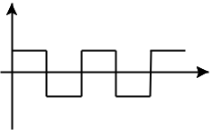

Output waveforms

t

Vin
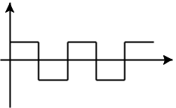

t

Output waveforms

+ |  | C |  | +
V |  | C |  | V
V | in | R |  | V
 | in | R | V | out
- |  |  | V | -
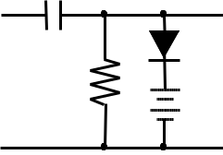

Vout
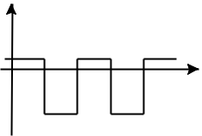

V

t

+ |  | C |  | +
V |  | C |  | V
V | in | R |  | V
 | in | R | V | out
- |  |  | V | -
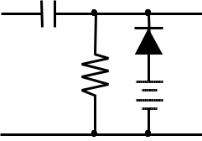

V
out
V | t
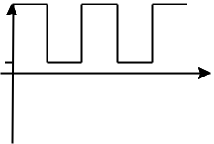

 |  |  |  |  | V
+ |  |  |  | + | out | + |  |  |  | +
 |  | C |  | + |  |  |  | C |  | +
V |  | C |  | V | t | V |  | C |  | V
V | in | R |  | V | t | V | in | R |  | V
 | in | R | V | out |  |  | in | R | V | out
- |  |  | V | - | V | - |  |  | V | -
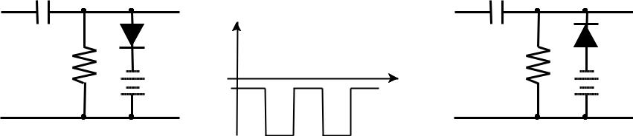

Figure 6.1: Clamping circuits
Experimental Procedure
Limiting Circuits

Vout
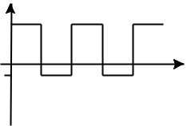

V

t

- You have a sinusoidal input which is 1 KHz and 16V peak-to-peak. Design a circuit that would limit the output to a maximum of 5V on the positive cycle and a minimum of 3V on the negative cycle. Test your circuit. Sketch the output.
- Assemble the circuit in Fig. 9 with Vin as a DC source. You need to vary Vin from -8 to
8V in the steps of 2V. Using “5V-fixed” terminals of the other power supply (the black one) make V1=5V. Use the other variable DC terminal to make V2=-3V. Measure the output (Vout). Fill out the table below and draw the relationship between Vin and Vout.

Table 6.1: Voltage limiting circuit result

Vin (V) -8 | -6 | -4 | -2 | 0 | 2 | 4 | 6 | 8

Vout(V)
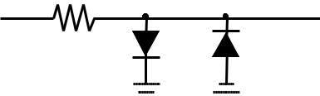

+ |  | R |  | +
V |  | R |  | V
V | in |  |  | V
 | in | V | V | out
- |  | V | V | -
- |  | 1 | 2 | -
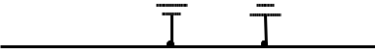

Figure. 6.2: Limiting Circuit

Clamping Circuits

- Connect the circuit of fig. 10 with C= 22

μF, R=300K

Ω

, and voltage V=0.

- Apply a square wave input signal of 12 V peak to peak at a frequency of 1 kHz.
- Use the DC-Coupling on the oscilloscope and sketch the output V_{out} and input V_{in}.

- Set the value of V to 6 volts and repeat steps a-c. Compare the results of steps c), and d).
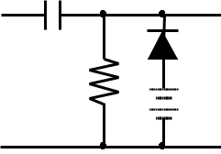

+ | C |  | +
 | C |  | ^{V}out
^{V} in R |  | V | ^{V}out
- |  | V | -

Figure. 6.3: Clamping Ciruit

  - If the diode was considered an ideal diode, what would be the clamping voltages for V=0 and V=6V.
QUESTIONS AND DISCUSSION
- How would you identify the anode of an unmarked diode using a DMM?
- Under what conditions will a diode turn-on? Explain.

Lab Exercise and Summary
Summary should cover Introduction, Procedure, Data Analysis and Evaluation.

Student’s Signature: ________________ Date: ________________

Cognitive Activity
Q1. In one sentence each: what does a clipper do to a waveform, and what does a clamper do? (2)
Ans:

Q2. A 12 Vpp square wave (±6 V) drives a silicon diode clamper (V = 0) that pushes the waveform upward so its negative peak sits at about −0.7 V. What are the output's maximum and minimum? (2)
Ans:

Q3. The same clamper now has a 6 V battery in the diode branch, oriented to raise the level. Where does the negative peak sit and what is the output range? (2)
Ans:

Q4. With C = 22 µF and R = 300 kΩ, calculate RC and compare it with the 1 kHz period. Why must RC be much larger than T? (2)
Ans:

Q5. Why must the CRO input be set to DC coupling to see the clamped output? (2)
Ans:

Obtained Marks | /10

Psychomotor Activity 1 — Experimental Setup

S. No | Criteria | Performance | Description | Marks
1 | Equipment Setup & Safety (4) | Level 4 | Switches ON and configures the function generator, CRO, DC supplies (5 V fixed and variable) and DMM correctly and independently, and completes the pre-power safety check (supply OFF, no loose wires, instructor approval) without reminders. | 4
1 | Equipment Setup & Safety (4) | Level 3 | Configures the equipment with minor errors or assistance and completes most of the safety checks after one reminder. | 3
1 | Equipment Setup & Safety (4) | Level 2 | Completes the setup with considerable assistance; safety checks are partial and need repeated reminders. | 2
1 | Equipment Setup & Safety (4) | Level 1 | Setup is incomplete and requires substantial assistance; safety checks are skipped or done unsafely. | 1
2 | Circuit/Breadboard Setup (4) | Level 4 | Builds the limiting and clamping circuits as per the figures with correct diode direction, capacitor polarity and bias voltages, independently. | 4
2 | Circuit/Breadboard Setup (4) | Level 3 | Circuits are mostly correct with minor errors (e.g. capacitor polarity or bias lead) corrected after a hint. | 3
2 | Circuit/Breadboard Setup (4) | Level 2 | Circuits are partially built and need considerable assistance. | 2
2 | Circuit/Breadboard Setup (4) | Level 1 | Major errors (capacitor reversed, wrong diode direction) and substantial assistance needed. | 1
3 | Parameter Setup (2) | Level 2 | Correctly sets the input signal (12 Vp-p, 1 kHz), bias voltages V1 = 5 V and V2 = -3 V (or V = 0 V/6 V) and DC coupling on the CRO before powering the circuit. | 2
3 | Parameter Setup (2) | Level 1 | Sets most of the required parameters with minor errors (e.g. wrong bias or coupling). | 1
Total Obtained |  |  |  | /10
If a student is absent:
Criteria | Description | Marks
Absent | Student is absent from the laboratory activity. | 0

Psychomotor Activity 2 — Implementation + Results

S. No | Criteria | Performance | Description | Marks
1 | Implementation (4) | Level 4 | Carries out the limiting circuit (Vin from -8 V to 8 V in 2 V steps) and the clamping circuit for V = 0 V and 6 V correctly and independently, following the procedure step by step. | 4
1 | Implementation (4) | Level 3 | Carries out the experiment with minor errors or assistance. | 3
1 | Implementation (4) | Level 2 | Partially carries out the experiment and requires considerable assistance. | 2
1 | Implementation (4) | Level 1 | Implementation is largely incomplete and requires substantial assistance. | 1
2 | Execution/Measurement & Safety (2) | Level 2 | Powers ON only after instructor approval, takes Vout for each Vin and the clamped waveform levels on the CRO correctly and follows all safety rules (isolate before changes, correct polarity) without reminders. | 2
2 | Execution/Measurement & Safety (2) | Level 1 | Takes the measurements with minor errors or assistance and needs reminders to follow the safety rules. | 1
3 | Results/Output (4) | Level 4 | Obtains correct Table 6.1, the Vin-Vout relationship and the clamped waveforms with correct DC shift and presents them clearly with units and labelled axes/sketches. | 4
3 | Results/Output (4) | Level 3 | Obtains mostly correct results with minor errors in readings or presentation. | 3
3 | Results/Output (4) | Level 2 | Obtains partially correct results with noticeable errors or omissions. | 2
3 | Results/Output (4) | Level 1 | Results are largely incorrect or incomplete and require substantial correction. | 1
Total Obtained |  |  |  | /10
If a student is absent:
Criteria | Description | Marks
Absent | Student is absent from the laboratory activity. | 0
Affective Activity — Lab Report + Viva Voce
S. No | Criteria | Performance | Description | Marks
1 | Lab Report Completeness & Organization (4) | Level 4 | Completes and organizes the report systematically (objective, equipment, circuit diagrams, Table 6.1, the Vin-Vout plot and waveform sketches, summary), demonstrating responsibility for the assigned laboratory work. | 4
1 | Lab Report Completeness & Organization (4) | Level 3 | Report is complete with minor omissions or organizational issues. | 3
1 | Lab Report Completeness & Organization (4) | Level 2 | Report is partially complete with several omissions. | 2
1 | Lab Report Completeness & Organization (4) | Level 1 | Report contains major omissions and shows limited responsibility toward the assigned work. | 1
2 | Results, Discussion & Conclusion (2) | Level 2 | Presents the results (Table 6.1, the Vin-Vout relationship and the clamped waveforms with correct DC shift) accurately and provides a clear discussion and conclusion based on the completed laboratory work. | 2
2 | Results, Discussion & Conclusion (2) | Level 1 | Presents the required results with minor errors or limited discussion/conclusion. | 1
3 | Viva Voce (4) | Level 4 | Clearly explains the difference between limiter and clamper and the effect of bias voltage V on the output, the implementation and the results, demonstrating individual responsibility and effective communication. | 4
3 | Viva Voce (4) | Level 3 | Explains most aspects of the assigned work correctly with minor difficulty. | 3
3 | Viva Voce (4) | Level 2 | Explains the basic aspects of the assigned work with some prompting. | 2
3 | Viva Voce (4) | Level 1 | Demonstrates limited involvement or understanding of the assigned work and requires substantial prompting. | 1
Total Obtained |  |  |  | /10
The student has not submitted the report and has not appeared in the Viva Voce.
Criteria | Description | Marks
Lab Report and Results Not Submitted | Student has not submitted the report and results file. | 0
Absent in Viva Voce | Student is absent from the viva voce. | 0

Instructor’s Signature: ________________ Date: ________________

Experiment 7

Light Emitting and Zener Diode
Objective:
- To Become familiar with the characteristic and use of a light emitting diode (LED) and Zener diode
Light Emitting Diode (LED):
A light-emitting diode (LED) is a semiconductor device that emits light when current flows through it. Electrons in the semiconductor recombine with electron holes, releasing energy in the form of photons. The color of the light (corresponding to the energy of the photons) is determined by the energy required for electrons to cross the band gap of the semiconductor. White light is obtained by using multiple semiconductors or a layer of light-emitting phosphor on the semiconductor device

PROCEDURE:

PART-1 LED Characteristics
- Construct the circuit of Fig. 7.1. Initially, set the supply to 0 V and record the measured value of the resistor R.

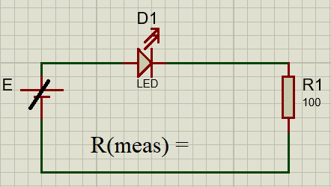
Figure 7.1

- Increase the supply voltage E until “first light” is noticed. Record the value of V_{D} and V_{R} using the DMM. Calculate the corresponding level of I_{D} using I_{D} = V_{R}/R

(Measured)V_{D} =

(Measured)V_{R} =

(Measured)I_{D} =

- Continue to increase the supply voltage E until “good Brightness” is obtained. Record the value of V_{D} and V_{R} using the DMM. Calculate the corresponding level of I_{D} using I_{D} = V_{R}/R

(Measured)V_{D} =

(Measured)V_{R} =

(Measured)I_{D} =

- Set the DC supply to the levels appearing in Table 7.1 and measure both V_{D} and V_{R}. Record the values of V_{D} and V_{R} in Table 7.1 and calculate the corresponding level of I_{D} using I_{D} = V_{R}/R

Table 7.1
E(V)
V_{D}(V)
V_{R}(V)
I_{D}=V_{R}/R(mA)

- Using the data of Table 7.1 sketch the curve of Id vs VD and ID vs VR on the graph as shown in fig. 7.2. Choose and appropriate scale of both Voltage and Current
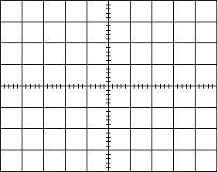

Operation of Zener Diode:
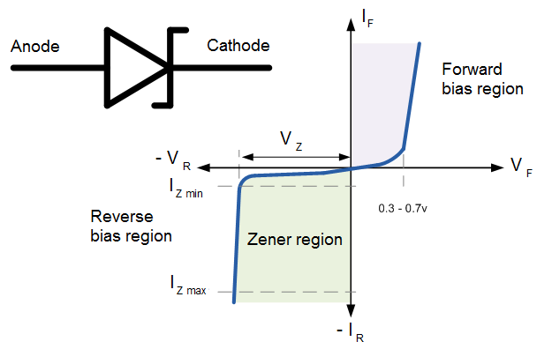
Zener diodes are a special kind of diode which permits current to flow in the forward direction. What makes them different from other diodes is that Zener diodes will also allow current to flow in the reverse direction when the voltage is above a certain value. This breakdown voltage is known as the Zener voltage. In a standard diode, the Zener voltage is high, and the diode is permanently damaged if a reverse current above that value is allowed to pass through it. Zener diodes are designed in a way where the Zener voltage is a much lower value. There is a controlled breakdown which does not damage the diode when a reverse current above the Zener voltage passes through a Zener diode.
Figure 7.3: Characteristics of Zener Diode
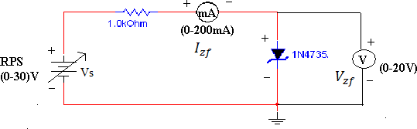
Figure 7.4: Forward Bias Condition

Procedure:
Forward Bias Condition:
- Connect the circuit as shown in Figure 7.4.
- Initially vary Vs in steps. Once the current starts increasing vary Vs in steps of 2V up to 20V. Note down the corresponding readings of Vz and Iz in Table 7.2.
Table 7.2: Forward Bias Condition:

Vs(volts) | Forward Voltage across the diode Vzf (volts) | Forward Current through the diode Izf (mA)
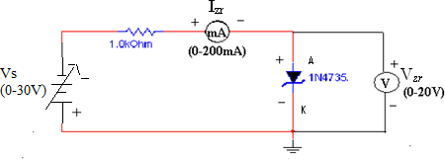
Figure 7.5: Reverse Bias Condition
Reverse Bias Condition:
- Connect the circuit as shown in Figure 7.5.
- Vary Vs gradually in steps of 2V up to 20V and note down the corresponding readings of Vz and Iz.
- Tabulate different reverse currents obtained for different reverse voltages.

Observations:
Table 7.3: Reverse Bias Condition:

Vs(volts) | Forward Voltage across the diode Vzf (volts) | Forward Current through the diode Izf (mA)

- With help of measured values in table 3 draw V-I characteristics of diode
Figure 7.6: V-I characteristics of diode

Lab Exercise and Summary
Summary should cover Introduction, Procedure, Data Analysis and Evaluation.

Student’s Signature: ________________ Date: ________________
Cognitive Activity
Q1. A red LED drops about 2 V. You want 10 mA from a 5 V supply. Calculate the series resistor and suggest the nearest standard value. (2)
Ans:

Q2. Why does an LED need a higher forward voltage than a silicon diode (0.7 V) before it glows, and why does a blue LED need more than a red one? (2)
Ans:

Q3. A 5.1 V Zener is fed from 12 V through a 470 Ω resistor (no load). Find the Zener current and the power the Zener dissipates. (2)
Ans:

Q4. In your reverse-bias table for the Zener, current suddenly shoots up while Vz barely changes. What is happening and why is this useful? (2)
Ans:

Q5. You accidentally connect the LED backwards across a 5 V supply. Will it glow? Is there any danger? (2)
Ans:

Obtained Marks | /10

Psychomotor Activity 1 — Experimental Setup

S. No | Criteria | Performance | Description | Marks
1 | Equipment Setup & Safety (4) | Level 4 | Switches ON and configures the DC power supply and DMMs (voltage and current modes) correctly and independently, and completes the pre-power safety check (supply OFF, no loose wires, instructor approval) without reminders. | 4
1 | Equipment Setup & Safety (4) | Level 3 | Configures the equipment with minor errors or assistance and completes most of the safety checks after one reminder. | 3
1 | Equipment Setup & Safety (4) | Level 2 | Completes the setup with considerable assistance; safety checks are partial and need repeated reminders. | 2
1 | Equipment Setup & Safety (4) | Level 1 | Setup is incomplete and requires substantial assistance; safety checks are skipped or done unsafely. | 1
2 | Circuit/Breadboard Setup (4) | Level 4 | Builds the LED circuit (Fig. 7.1) and the Zener forward/reverse circuits as per the schematics with correct polarity and series resistor, independently. | 4
2 | Circuit/Breadboard Setup (4) | Level 3 | Circuits are mostly correct with minor errors (e.g. resistor value or loose lead) corrected after a hint. | 3
2 | Circuit/Breadboard Setup (4) | Level 2 | Circuits are partially built and need considerable assistance. | 2
2 | Circuit/Breadboard Setup (4) | Level 1 | Major errors (no resistor, reversed LED or Zener) and substantial assistance needed. | 1
3 | Parameter Setup (2) | Level 2 | Correctly sets the supply starting at 0 V, the measured value of R and the DMM ranges for VD and VR before powering the circuit. | 2
3 | Parameter Setup (2) | Level 1 | Sets most of the required parameters with minor errors (e.g. wrong start value or meter range). | 1
Total Obtained |  |  |  | /10

If a student is absent:
Criteria | Description | Marks
Absent | Student is absent from the laboratory activity. | 0

Psychomotor Activity 2 — Implementation + Results

S. No | Criteria | Performance | Description | Marks
1 | Implementation (4) | Level 4 | Carries out the LED first-light/good-brightness tests and the Zener forward and reverse bias measurements correctly and independently, following the procedure step by step. | 4
1 | Implementation (4) | Level 3 | Carries out the experiment with minor errors or assistance. | 3
1 | Implementation (4) | Level 2 | Partially carries out the experiment and requires considerable assistance. | 2
1 | Implementation (4) | Level 1 | Implementation is largely incomplete and requires substantial assistance. | 1
2 | Execution/Measurement & Safety (2) | Level 2 | Powers ON only after instructor approval, takes VD, VR and ID = VR/R for the LED, and Vz and Iz for the Zener correctly and follows all safety rules (isolate before changes, correct polarity) without reminders. | 2
2 | Execution/Measurement & Safety (2) | Level 1 | Takes the measurements with minor errors or assistance and needs reminders to follow the safety rules. | 1
3 | Results/Output (4) | Level 4 | Obtains correct Table 7.1, the ID-VD curve of the LED and the Zener characteristic with the Zener voltage marked and presents them clearly with units and labelled axes/sketches. | 4
3 | Results/Output (4) | Level 3 | Obtains mostly correct results with minor errors in readings or presentation. | 3
3 | Results/Output (4) | Level 2 | Obtains partially correct results with noticeable errors or omissions. | 2
3 | Results/Output (4) | Level 1 | Results are largely incorrect or incomplete and require substantial correction. | 1
Total Obtained |  |  |  | /10
If a student is absent:
Criteria | Description | Marks
Absent | Student is absent from the laboratory activity. | 0
Affective Activity — Lab Report + Viva Voce
S. No | Criteria | Performance | Description | Marks
1 | Lab Report Completeness & Organization (4) | Level 4 | Completes and organizes the report systematically (objective, equipment, circuit diagrams, Table 7.1, Zener tables and the I-V graphs, summary), demonstrating responsibility for the assigned laboratory work. | 4
1 | Lab Report Completeness & Organization (4) | Level 3 | Report is complete with minor omissions or organizational issues. | 3
1 | Lab Report Completeness & Organization (4) | Level 2 | Report is partially complete with several omissions. | 2
1 | Lab Report Completeness & Organization (4) | Level 1 | Report contains major omissions and shows limited responsibility toward the assigned work. | 1
2 | Results, Discussion & Conclusion (2) | Level 2 | Presents the results (Table 7.1, the ID-VD curve of the LED and the Zener characteristic with the Zener voltage marked) accurately and provides a clear discussion and conclusion based on the completed laboratory work. | 2
2 | Results, Discussion & Conclusion (2) | Level 1 | Presents the required results with minor errors or limited discussion/conclusion. | 1
3 | Viva Voce (4) | Level 4 | Clearly explains the working of an LED and the Zener breakdown region, the implementation and the results, demonstrating individual responsibility and effective communication. | 4
3 | Viva Voce (4) | Level 3 | Explains most aspects of the assigned work correctly with minor difficulty. | 3
3 | Viva Voce (4) | Level 2 | Explains the basic aspects of the assigned work with some prompting. | 2
3 | Viva Voce (4) | Level 1 | Demonstrates limited involvement or understanding of the assigned work and requires substantial prompting. | 1
Total Obtained |  |  |  | /10
The student has not submitted the report and has not appeared in the Viva Voce.
Criteria | Description | Marks
Lab Report and Results Not Submitted | Student has not submitted the report and results file. | 0
Absent in Viva Voce | Student is absent from the viva voce. | 0

Instructor’s Signature: ________________ Date: ________________

Experiment 8
DC Analysis of Bipolar Junction Transistor (BJT)
OBJECTIVE:
- To determine transistor type (NPN, PNP). Terminals, and material using a digital multimeter (DMM).
- To study and verify the functionality of a Transistor to plot Volt-Ampere Characteristics of a Transistor

Introduction
A Bipolar Junction Transistor, or BJT is a three terminal device having two PN-junctions connected together in series. Each terminal is given a name to identify it and these are known as the Emitter (E), Base (B) and Collector (C). There are two basic types of bipolar transistor construction, NPN and PNP, which basically describes the physical arrangement of the P- type and N-type semiconductor materials from which they are made.
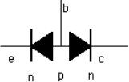
The basic transistor consists of two diodes back to back. If the two p doped regions are next to each other then what results is a npn transistor.
Figure 8.4: NPN Transistor

Two laboratory diodes wired back-to-back will NOT make a transistor. In a real transistor, the region of the two p regions is very narrow or thin so that the carriers can diffuse across the region freely. The symbol for the npn transistor is shown below.
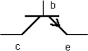
Figure 8.5: NPN Transistor Symbol
Tip for remembering: The arrow on the npn transistor is Not Pointed in.
When the two n regions are next to each other (as below) then one has a pnp transistor.
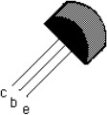
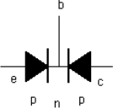
It should be clear that one of the diodes in a transistor is in the forward direction emitter- collector while one of the diodes is in the reverse direction. The symbol for the pnp transistor is given below.
Figure 8.6: PNP Transistor
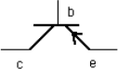
Figure 8.7: PNP Transistor Symbol

So the direction of the arrow is reverse from the npn transistor.
Transistors like the 2N2222 or PN2907 come in a variety of cases and either metal or plastic. One style is of plastic case or package is indicated below:
Figure 8.8: transistor package
Or the bottom view is as follows:
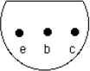
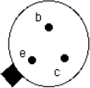
Finally, the view from the bottom of a transistor in a metal package is like as shown below:
Bipolar Transistors are "CURRENT" Amplifying or current regulating devices that control the amount of current flowing through them in proportion to the amount of biasing current applied to their base terminal. The principle of operation of the two transistor types NPN and PNP, is exactly the same, the only difference being in the biasing (base current) and the polarity of the power supply for each type.
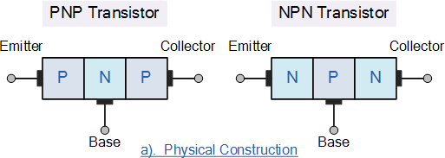

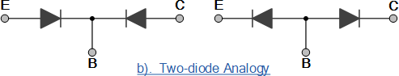

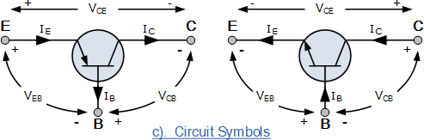

The symbols for both the NPN and PNP bipolar transistor are shown above along with the direction of conventional current flow. The direction of the arrow in the symbol shows current flow between the base and emitter terminal, pointing from the positive P-type region to the negative N-type region, exactly the same as for the standard diode symbol. For normal operation, the emitter-base junction is forward-biased and the collector-base junction is reverse-biased.

Transistor Configurations
There are three possible configurations possible when a transistor is connected in a circuit: (a) Common base, (b) Common emitter (c) Common collector. We will be focusing on the first two configurations in this experiment. The behavior of a transistor can be represented by DC current-voltage (V-I) curves, called the static characteristic curves of the device. The three important characteristics of a transistor are: (i) Input characteristics, (ii) Output characteristics and (iii) Transfer Characteristics. These characteristics give information about various transistor parameters, e.g. Input and output dynamic resistance, current amplification factors, etc.
Common Emitter Configuration: When a transistor is used in common emitter configuration the input is fed between its base and emitter terminal and output is taken between the collector and emitter terminal as shown in fig.3.1 shows the circuit for determining the input and output characteristics of NPN transistor in common emitter configuration.

Procedure:

Part 1. Determination of the transistor’s type, Terminal and Materials

The following procedure will determine the type of a transistor, the terminals of a transistor, and the material from which it is made. The procedure will utilize the diode testing found on many modern multimeters. If no such scale is available the resistance scales of the meter may be used.
- Label the transistor terminals of the fig shown below. Use the transistor without terminal identification for this part of the experiment

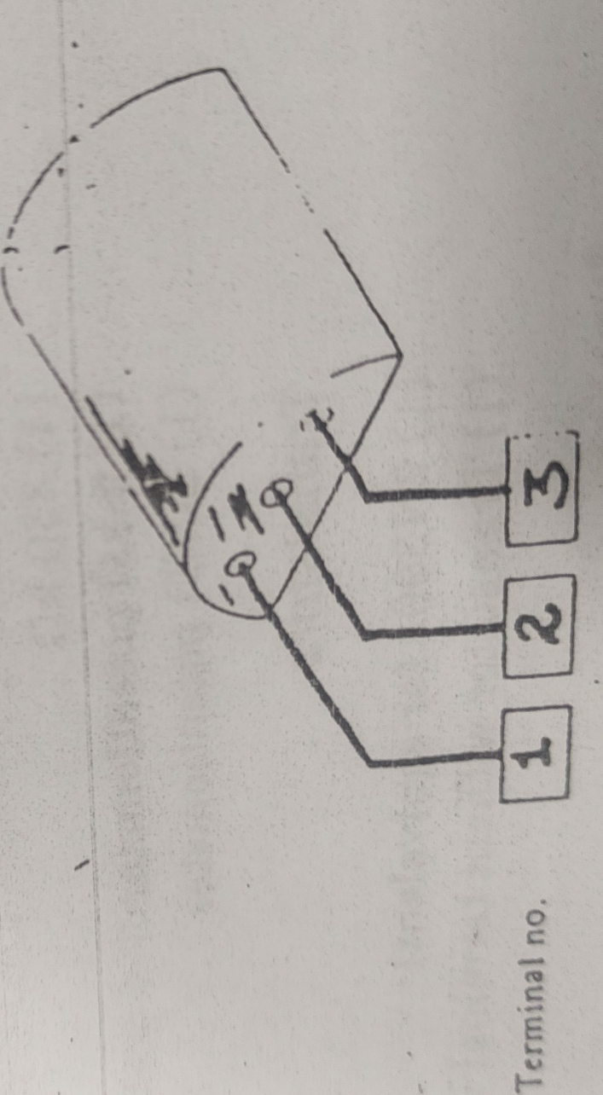

Terminal identity
- Set the selector switch of the multimeter to the diode scale and connect the positive lead of the meter to terminal 1 and negative lead to terminal 2; record your reading in table 8.1
Table 8.1
Meter leads Connected to BJT |  |  | Diode Check Reading
Sr. no. | Positive | Negative | Diode Check Reading
1 | 1 | 2
2 | 1 | 3
3 | 2 | 1
4 | 2 | 3
5 | 3 | 1
6 | 3 | 2

- Based on the reading noted in table 8.1, record the number of the bas terminal in table 8.2
Table 8.2

Base Terminal

Transistor Type

Collector Terminal

Emitter Terminal

Transistor Material

Part 2. The Collector Characteristics
- Construct the network as shown below

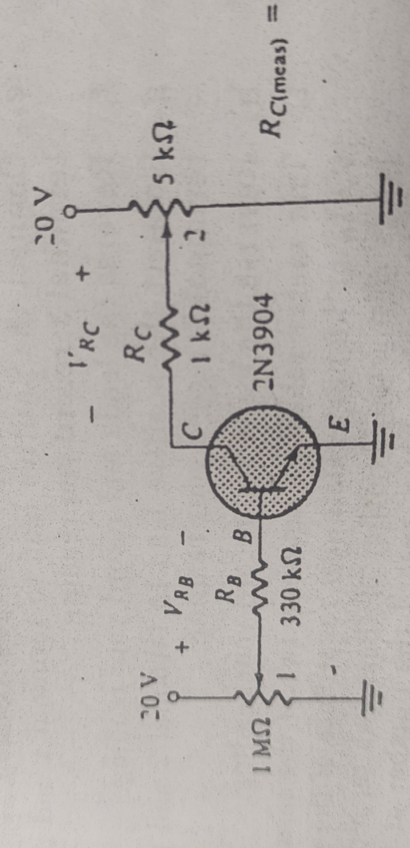
- Set the voltage V_{RB} to 3.3Vby varying the 1MΩ potentiometer, this adjustment will set I_{B}= V_{RB}/R_{B} to 10uA as indicated in Table 8.3
- Then set the VCE to 2V by varying the 5KΩ potentiometer as required by the first line of table 8.3. Record the values of voltages and current mentioned in table 8.3
- Using the data of Table 8.3, plot the collector characteristics of the transistor on the graph shown after table. That plot is I_{C} versus V_{CE} for the various values of I_{B}. Choose an appropriate scale.
Table 8.3
V_{RB}  _{(meas)} | I_{B}  _{(calc)} | V_{CE}  _{(meas)} | V_{RC}  _{(meas)} | I_{C}  _{(calc)} | V_{BE}  _{(meas)} | I_{E}  _{(calc)} | α  _{(calc)} | β  _{(calc)}
3.3V | 10uA | 2
3.3V | 10uA | 4
3.3V | 10uA | 6
3.3V | 10uA | 8
3.3V | 10uA | 10
3.3V | 10uA | 12
3.3V | 10uA | 14
6.6V | 20uA | 2
6.6V | 20uA | 4
6.6V | 20uA | 6
6.6V | 20uA | 8
6.6V | 20uA | 10
6.6V | 20uA | 12
6.6V | 20uA | 14
9.9V | 30uA | 2
9.9V | 30uA | 4
9.9V | 30uA | 6
9.9V | 30uA | 8
9.9V | 30uA | 10
9.9V | 30uA | 12
9.9V | 30uA | 14

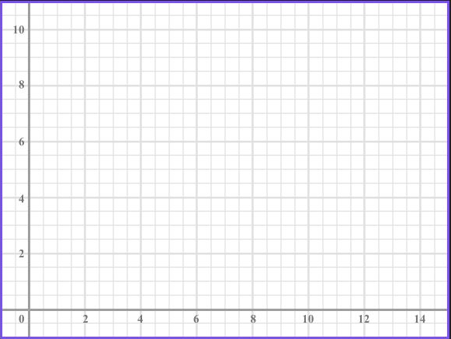
Figure 8.9 characteristics curve from experiment data

Lab Exercise and Summary
Summary should cover Introduction, Procedure, Data Analysis and Evaluation.

Student’s Signature: ________________ Date: ________________
Cognitive Activity
Q1. On the DMM diode scale, the red lead on terminal 1 reads about 0.65 V to both other terminals, while the black lead on terminal 1 reads OL to both. Which terminal is terminal 1 and is the transistor NPN or PNP? (2)
Ans:

Q2. Why can't you build a working transistor by wiring two separate diodes back-to-back? (2)
Ans:

Q3. IB = 20 µA and β = 150. Find IC and IE. (2)
Ans:

Q4. On the collector characteristics, IC is almost flat for VCE above about 0.3 V. Which region is this and what actually sets IC there? (2)
Ans:

Q5. You measure VCE = 0.1 V while IB is large. Which region is the transistor in and how does it behave as a switch? (2)
Ans:

Obtained Marks | /10

Psychomotor Activity 1 — Experimental Setup

S. No | Criteria | Performance | Description | Marks
1 | Equipment Setup & Safety (4) | Level 4 | Switches ON and configures the DMM (diode-test mode), DC power supply and the transistor with its pin diagram correctly and independently, and completes the pre-power safety check (supply OFF, no loose wires, instructor approval) without reminders. | 4
1 | Equipment Setup & Safety (4) | Level 3 | Configures the equipment with minor errors or assistance and completes most of the safety checks after one reminder. | 3
1 | Equipment Setup & Safety (4) | Level 2 | Completes the setup with considerable assistance; safety checks are partial and need repeated reminders. | 2
1 | Equipment Setup & Safety (4) | Level 1 | Setup is incomplete and requires substantial assistance; safety checks are skipped or done unsafely. | 1
2 | Circuit/Breadboard Setup (4) | Level 4 | Identifies the type and terminals with the DMM and builds the bias circuit as per the schematic with correct E-B-C pin placement and resistor values, independently. | 4
2 | Circuit/Breadboard Setup (4) | Level 3 | Terminals and circuit are mostly correct with minor errors (e.g. one pin confused) corrected after a hint. | 3
2 | Circuit/Breadboard Setup (4) | Level 2 | Terminals or circuit are partially correct and need considerable assistance. | 2
2 | Circuit/Breadboard Setup (4) | Level 1 | Major errors (wrong pin-out, wrong polarity) and substantial assistance needed. | 1
3 | Parameter Setup (2) | Level 2 | Correctly sets the supply voltages, base and collector resistor values and the DMM ranges for VRB, VCE and VRC before powering the circuit. | 2
3 | Parameter Setup (2) | Level 1 | Sets most of the required parameters with minor errors (e.g. wrong supply value or meter range). | 1
Total Obtained |  |  |  | /10
If a student is absent:
Criteria | Description | Marks
Absent | Student is absent from the laboratory activity. | 0

Psychomotor Activity 2 — Implementation + Results
S. No | Criteria | Performance | Description | Marks
1 | Implementation (4) | Level 4 | Carries out the transistor type/terminal identification and the DC bias measurements correctly and independently, following the procedure step by step. | 4
1 | Implementation (4) | Level 3 | Carries out the experiment with minor errors or assistance. | 3
1 | Implementation (4) | Level 2 | Partially carries out the experiment and requires considerable assistance. | 2
1 | Implementation (4) | Level 1 | Implementation is largely incomplete and requires substantial assistance. | 1
2 | Execution/Measurement & Safety (2) | Level 2 | Powers ON only after instructor approval, takes VRB, VCE, VRC and VBE readings and the calculated IB, IC and IE correctly and follows all safety rules (isolate before changes, correct polarity) without reminders. | 2
2 | Execution/Measurement & Safety (2) | Level 1 | Takes the measurements with minor errors or assistance and needs reminders to follow the safety rules. | 1
3 | Results/Output (4) | Level 4 | Obtains correct the transistor type table, the measured/calculated values table and the IC-VCE characteristic curve and presents them clearly with units and labelled axes/sketches. | 4
3 | Results/Output (4) | Level 3 | Obtains mostly correct results with minor errors in readings or presentation. | 3
3 | Results/Output (4) | Level 2 | Obtains partially correct results with noticeable errors or omissions. | 2
3 | Results/Output (4) | Level 1 | Results are largely incorrect or incomplete and require substantial correction. | 1
Total Obtained |  |  |  | /10

If a student is absent:
Criteria | Description | Marks
Absent | Student is absent from the laboratory activity. | 0
Affective Activity — Lab Report + Viva Voce
S. No | Criteria | Performance | Description | Marks
1 | Lab Report Completeness & Organization (4) | Level 4 | Completes and organizes the report systematically (objective, equipment, diode-check tables, bias circuit diagram, data table and the characteristic curve, summary), demonstrating responsibility for the assigned laboratory work. | 4
1 | Lab Report Completeness & Organization (4) | Level 3 | Report is complete with minor omissions or organizational issues. | 3
1 | Lab Report Completeness & Organization (4) | Level 2 | Report is partially complete with several omissions. | 2
1 | Lab Report Completeness & Organization (4) | Level 1 | Report contains major omissions and shows limited responsibility toward the assigned work. | 1
2 | Results, Discussion & Conclusion (2) | Level 2 | Presents the results (the transistor type table, the measured/calculated values table and the IC-VCE characteristic curve) accurately and provides a clear discussion and conclusion based on the completed laboratory work. | 2
2 | Results, Discussion & Conclusion (2) | Level 1 | Presents the required results with minor errors or limited discussion/conclusion. | 1
3 | Viva Voce (4) | Level 4 | Clearly explains how to identify NPN/PNP and terminals and how IB controls IC, the implementation and the results, demonstrating individual responsibility and effective communication. | 4
3 | Viva Voce (4) | Level 3 | Explains most aspects of the assigned work correctly with minor difficulty. | 3
3 | Viva Voce (4) | Level 2 | Explains the basic aspects of the assigned work with some prompting. | 2
3 | Viva Voce (4) | Level 1 | Demonstrates limited involvement or understanding of the assigned work and requires substantial prompting. | 1
Total Obtained |  |  |  | /10
The student has not submitted the report and has not appeared in the Viva Voce.
Criteria | Description | Marks
Lab Report and Results Not Submitted | Student has not submitted the report and results file. | 0
Absent in Viva Voce | Student is absent from the viva voce. | 0

Instructor’s Signature: ________________ Date: ________________
Experiment 9
Determination of Q-Point for fixed and voltage divider bias configuration of a BJT
OBJECTIVE:
To determine the quiescent operating condition of the fixed and voltage divider bias BJT configuration
Introduction:
In the previous introduction to the amplifier tutorial, we saw that a family of curves known commonly as the Output Characteristic Curves, relate the transistors Collector Current (Ic), to its Collector Voltage (Vce) for different values of the transistors Base Current (Ib). All types of transistor amplifiers operate using AC signal inputs which alternate between a positive value and a negative value so some way of “presetting” the amplifier circuit to operate between these two maximum or peak values is required. This is achieved using a process known as Biasing. Biasing is very important in amplifier design as it establishes the correct operating point of the transistor amplifier ready to receive signals, thereby reducing any distortion to the output signal.
We also saw that a static or DC load line can be drawn onto these output characteristics curves to show all the possible operating points of the transistor from fully “ON” to fully “OFF”, and to which the quiescent operating point or Q-point of the amplifier can be found.
The aim of any small signal amplifier is to amplify all of the input signal with the minimum amount of distortion possible to the output signal, in other words, the output signal must be an exact reproduction of the input signal but only bigger (amplified).
To obtain low distortion when used as an amplifier the operating quiescent point needs to be correctly selected. This is in fact the DC operating point of the amplifier and its position may be established at any point along the load line by a suitable biasing arrangement.
Fixed Bias Configuration:
The steady state operation of a bipolar transistor depends a great deal on its base current, collector voltage, and collector current values. Therefore, if the transistor is to operate correctly as a linear amplifier, it must be properly biased around its operating point as improper transistor biasing will result in a distorted output.
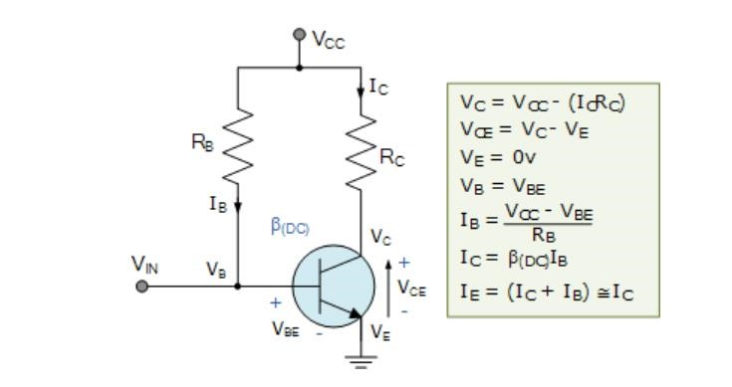

The circuit shown is called as a “fixed base bias circuit”, because the transistors base current, IB remains constant for given values of Vcc, and therefore the transistors operating point must also remain fixed. This two resistor biasing network is used to establish the initial operating region of the transistor using a fixed current bias. This type of transistor biasing arrangement is also beta dependent biasing as the steady-state condition of operation is a function of the transistors beta β value, so the biasing point will vary over a wide range for transistors of the same type as the characteristics of the transistors will not be exactly the same. The emitter diode of the transistor is forward biased by applying the required positive base bias voltage via the current limiting resistor RB. Assuming a standard bipolar transistor, the forward base-emitter voltage drop would be 0.7V. Then the value of RB is simply: (VCC – VBE)/IB where IB is defined as IC/β. Voltage Divider configuration
The single stage common emitter amplifier circuit shown above uses what is commonly called “Voltage Divider Biasing”. This type of biasing arrangement uses two resistors as a potential divider network across the supply with their center point supplying the required Base bias voltage to the transistor. Voltage divider biasing is commonly used in the design of bipolar transistor amplifier circuits.
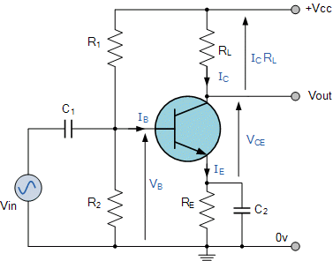
Figure 9.1: Voltage divider Bias

This method of biasing the transistor greatly reduces the effects of varying Beta, ( β ) by holding the Base bias at a constant steady voltage level allowing for best stability. The quiescent Base voltage (Vb) is determined by the potential divider network formed by the two resistors, R1, R2 and the power supply voltage Vcc as shown with the current flowing through both resistors.
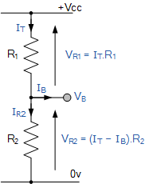

Then the total resistance R_{T} will be equal to R1 + R2 giving the current as i = Vcc/R_{T}. The voltage level generated at the junction of resistors R1 and R2 holds the Base voltage (Vb) constant at a value below the supply voltage.
Then the potential divider network used in the common emitter amplifier circuit divides the supply voltage in proportion to the resistance. This bias reference voltage can be easily calculated using the simple voltage divider formula below:

Transistor Bias Voltage
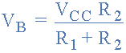

The same supply voltage, (Vcc) also determines the maximum Collector current, Ic when the transistor is switched fully “ON” (saturation), Vce = 0. The Base current Ib for the transistor is found from the Collector current, Ic and the DC current gain Beta, β of the transistor.

Beta Value
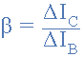

Beta is sometimes referred to as h_{FE} which is the transistors forward current gain in the common emitter configuration. Beta has no units as it is a fixed ratio of the two currents, Ic and Ib so a small change in the Base current will cause a large change in the Collector current.
One final point about Beta. Transistors of the same type and part number will have large variations in their Beta value. For example, the BC107 NPN Bipolar transistor has a DC current gain Beta value of between 110 and 450 (data sheet value). So, one BC107 may have a Beta value of 110, while another one may have a Beta value of 450, but they are both BC107 npn transistors. This is because Beta is a characteristic of the transistor’s construction and not of its operation.
As the Base/Emitter junction is forward-biased, the Emitter voltage, Ve will be one junction voltage drop different to the Base voltage. If the voltage across the Emitter resistor is known then the Emitter current, Ie can be easily calculated using Ohm’s Law. The Collector current, Ic can be approximated, since it is almost the same value as the Emitter current.

Common Emitter Amplifier Example
A common emitter amplifier circuit has a load resistance, R_{L} of 1.2kΩ and a supply voltage of 12v. Calculate the maximum Collector current (Ic) flowing through the load resistor when the transistor is switched fully “ON” (saturation), assume Vce = 0. Also find the value of the Emitter resistor, R_{E} if it has a voltage drop of 1v across it. Calculate the values of all the other circuit resistors assuming a standard NPN silicon transistor.

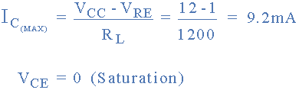

This then establishes point “A” on the Collector current vertical axis of the characteristics curves and occurs when Vce = 0. When the transistor is switched fully “OFF”, their is no voltage drop across either resistor R_{E} or R_{L} as no current is flowing through them. Then the voltage drop across the transistor, Vce is equal to the supply voltage, Vcc. This establishes point “B” on the horizontal axis of the characteristic’s curves.
Generally, the quiescent Q-point of the amplifier is with zero input signal applied to the Base, so the Collector sits about half-way along the load line between zero volts and the supply voltage, (Vcc/2). Therefore, the Collector current at the Q-point of the amplifier will be given as:
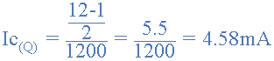

This static DC load line produces a straight line equation whose slope is given as: -1/(R_{L} + R_{E}) and that it crosses the vertical Ic axis at a point equal to Vcc/(R_{L} + R_{E}). The actual position of the Q-point on the DC load line is determined by the mean value of Ib.
As the Collector current, Ic of the transistor is also equal to the DC gain of the transistor (Beta), times the Base current (β*Ib), if we assume a Beta (β) value for the transistor of say 100, (one hundred is a reasonable average value for low power signal transistors) the Base current Ib flowing into the transistor will be given as:
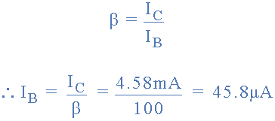
Instead of using a separate Base bias supply, it is usual to provide the Base Bias Voltage from the main supply rail (Vcc) through a dropping resistor, R1. Resistors, R1 and R2 can now be chosen to give a suitable quiescent Base current of 45.8μA or 46μA rounded off to the nearest integer. The current flowing through the potential divider circuit has to be large compared to the actual Base current, Ib, so that the voltage divider network is not loaded by the Base current flow.
A general rule of thumb is a value of at least 10 times Ib flowing through the resistor R2. Transistor Base/Emitter voltage, Vbe is fixed at 0.7V (silicon transistor) then this gives the value of R2 as:
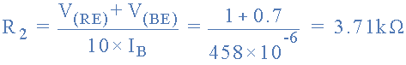
If the current flowing through resistor R2 is 10 times the value of the Base current, then the current flowing through resistor R1 in the divider network must be 11 times the value of the Base current. That is: I_{R2} + Ib.
Thus the voltage across resistor R1 is equal to Vcc – 1.7v (V_{RE} + 0.7 for silicon transistor) which is equal to 10.3V, therefore R1 can be calculated as:
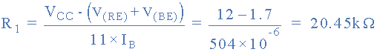
The value of the Emitter resistor, R_{E} can be easily calculated using Ohm’s Law. The current flowing through R_{E} is a combination of the Base current, Ib and the Collector current Ic and is given as:
Resistor, R_{E} is connected between the transistors Emitter terminal and ground, and we said previously that there is a voltage drop of 1 volt across it. Thus the value of the Emitter resistor, R_{E} is calculated as:
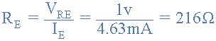
So, for our example above, the preferred values of the resistors chosen to give a tolerance of 5% (E24) are:
Then, our original Common Emitter Amplifier circuit above can be rewritten to include the values of the components that we have just calculated above.
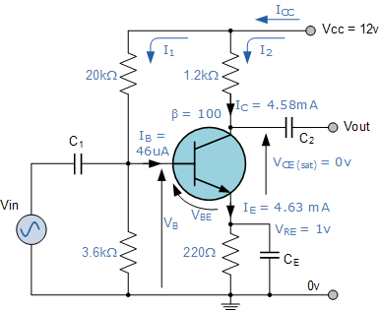

Amplifier Coupling Capacitors
In Common Emitter Amplifier circuits, capacitors C1 and C2 are used as Coupling Capacitors to separate the AC signals from the DC biasing voltage. This ensures that the bias condition set up for the circuit to operate correctly is not affected by any additional amplifier stages, as the capacitors will only pass AC signals and block any DC component. The output AC signal is then superimposed on the biasing of the following stages. Also a bypass capacitor, C_{E} is included in the Emitter leg circuit.
This capacitor is effectively an open circuit component for DC biasing conditions, which means that the biasing currents and voltages are not affected by the addition of the capacitor maintaining a good Q-point stability.
However, this parallel connected bypass capacitor effectively becomes a short circuit to the Emitter resistor at high frequency signals due to its reactance. Thus only R_{L} plus a very small internal resistance acts as the transistors load increasing voltage gain to its maximum. Generally, the value of the bypass capacitor, C_{E} is chosen to provide a reactance of at most, 1/10th the value of R_{E} at the lowest operating signal frequency.

Common Emitter Voltage Gain
The Voltage Gain of the common emitter amplifier is equal to the ratio of the change in the input voltage to the change in the amplifiers output voltage.
Then ΔV_{L} is Vout and ΔV_{B} is Vin. But voltage gain is also equal to the ratio of the signal resistance in the Collector to the signal resistance in the Emitter and is given as:
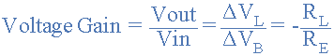
We mentioned earlier that as the signal frequency increases the bypass capacitor, C_{E} starts to short out the Emitter resistor due to its reactance. Then at high frequencies R_{E} = 0, making the gain infinite.
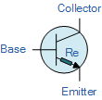

However, bipolar transistors have a small internal resistance built into their Emitter region called R_{e}. The transistors semiconductor material offers an internal resistance to the flow of current through it and is generally represented by a small resistor symbol shown inside the main transistor symbol.
Transistor data sheets tell us that for a small signal bipolar transistors this internal resistance is the product of 25mV ÷ Ie (25mV being the internal volt drop across the Emitter junction layer), then for our common Emitter amplifier circuit above this resistance value will be equal to:
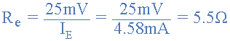
This internal Emitter leg resistance will be in series with the external Emitter resistor, R_{E}, then the equation for the transistors actual gain will be modified to include this internal resistance so will be:
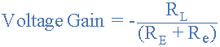
At low frequency signals the total resistance in the Emitter leg is equal to R_{E} + R_{e}. At high frequency, the bypass capacitor shorts out the Emitter resistor leaving only the internal resistance R_{e} in the Emitter leg resulting in a high gain. Then for our common emitter amplifier circuit above, the gain of the circuit at both low and high signal frequencies is given as:

Gain at Low Frequencies
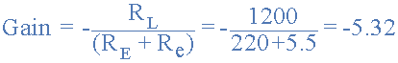

Gain at High Frequencies
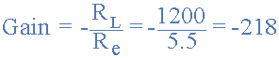
One final point, the voltage gain is dependent only on the values of the Collector resistor, R_{L} and the Emitter resistance, (R_{E} + R_{e}) it is not affected by the current gain Beta, β (h_{FE}) of the transistor.

Common Emitter Amplifier Summary
The Common Emitter Amplifier circuit has a resistor in its Collector circuit. The current flowing through this resistor produces the voltage output of the amplifier. The value of this resistor is chosen so that at the amplifiers quiescent operating point, Q-point this output voltage lies half way along the transistors load line.
The Base of the transistor used in a common emitter amplifier is biased using two resistors as a potential divider network. This type of biasing arrangement is commonly used in the design of bipolar transistor amplifier circuits and greatly reduces the effects of varying Beta, ( β ) by holding the Base bias at a constant steady voltage. This type of biasing produces the greatest stability.
A resistor can be included in the emitter leg in which case the voltage gain becomes -R_{L}/R_{E}. If there is no external Emitter resistance, the voltage gain of the amplifier is not infinite as there is a very small internal resistance, R_{e} in the Emitter leg. The value of this internal resistance is equal to 25mV/I_{E}

Activity:

Activity: 1
Using 2 NPN transistor (2N3904 and 2N4401) calculate the following for both configuration:
|𝐵(4401) − 𝐵(3904)|
%∆𝐵 =
|𝐵(3904)|
|𝐼𝑐(4401) − 𝐼𝑐(3904)|
%∆𝐼𝐶 =
|𝐼𝑐(3904)|
|𝑉𝑐𝑒(4401) − 𝑉𝑐𝑒(3904)|
%∆𝑉𝑐𝑒 =
|𝑉𝑐𝑒(3904)|
|𝐼𝐵(4401) − 𝐼𝐵(3904)|
%∆𝐼𝐵 =
|𝐼𝐵(3904)| • Fixed Bias Configuration:
%∆𝐵 =
%∆𝐼𝐶 =
%∆𝑉𝑐𝑒 =
%∆𝐼𝐵 =

• Voltage Divider Bias Configuration:
%∆𝐵 =
%∆𝐼𝐶 =
%∆𝑉𝑐𝑒 =
%∆𝐼𝐵 =

Lab Exercise and Summary
Summary should cover Introduction, Procedure, Data Analysis and Evaluation.

Cognitive Activity

Q1. Fixed bias: VCC = 12 V, RB = 470 kΩ, RC = 2.2 kΩ, β = 100, VBE = 0.7 V. Find IB, IC and VCE. (2)
Ans:

Q2. Your lab partner swaps in a transistor with β = 200 in the same fixed-bias circuit. Recalculate IC and VCE. What danger do you see? (2)
Ans:

Q3. Voltage divider bias: VCC = 12 V, R1 = 22 kΩ, R2 = 4.7 kΩ, RC = 2.2 kΩ, RE = 1 kΩ (β large). Find VB, VE, IC and VCE. (2)
Ans:

Q4. Repeat the β swap (100 to 200) for the divider circuit of Q3. Why is IC almost unchanged? (2)
Ans:

Q5. Find the DC load-line end points for the fixed-bias circuit in Q1 and say whether its Q-point is well placed for a symmetrical swing. (2)
Ans:

Obtained Marks | /10

Psychomotor Activity 1 — Experimental Setup

S. No | Criteria | Performance | Description | Marks
1 | Equipment Setup & Safety (4) | Level 4 | Switches ON and configures the DC power supply, DMMs and the breadboard with the transistor (supply OFF) correctly and independently, and completes the pre-power safety check (supply OFF, no loose wires, instructor approval) without reminders. | 4
1 | Equipment Setup & Safety (4) | Level 3 | Configures the equipment with minor errors or assistance and completes most of the safety checks after one reminder. | 3
1 | Equipment Setup & Safety (4) | Level 2 | Completes the setup with considerable assistance; safety checks are partial and need repeated reminders. | 2
1 | Equipment Setup & Safety (4) | Level 1 | Setup is incomplete and requires substantial assistance; safety checks are skipped or done unsafely. | 1
2 | Circuit/Breadboard Setup (4) | Level 4 | Builds the fixed bias and voltage divider bias circuits as per the schematics with correct resistor values, transistor pins and supply polarity, independently. | 4
2 | Circuit/Breadboard Setup (4) | Level 3 | Circuits are mostly correct with minor errors (e.g. resistor value or pin position) corrected after a hint. | 3
2 | Circuit/Breadboard Setup (4) | Level 2 | Circuits are partially built and need considerable assistance. | 2
2 | Circuit/Breadboard Setup (4) | Level 1 | Major errors or omissions in the circuits and substantial assistance needed. | 1
3 | Parameter Setup (2) | Level 2 | Correctly sets VCC, the measured values of RB, R1, R2, RC and RE and the DMM ranges before powering the circuit. | 2
3 | Parameter Setup (2) | Level 1 | Sets most of the required parameters with minor errors (e.g. resistor values not measured). | 1
Total Obtained |  |  |  | /10
If a student is absent:
Criteria | Description | Marks
Absent | Student is absent from the laboratory activity. | 0

Psychomotor Activity 2 — Implementation + Results
S. No | Criteria | Performance | Description | Marks
1 | Implementation (4) | Level 4 | Carries out the fixed bias and voltage divider bias measurements of IB, IC, VCE and VBE correctly and independently, following the procedure step by step. | 4
1 | Implementation (4) | Level 3 | Carries out the experiment with minor errors or assistance. | 3
1 | Implementation (4) | Level 2 | Partially carries out the experiment and requires considerable assistance. | 2
1 | Implementation (4) | Level 1 | Implementation is largely incomplete and requires substantial assistance. | 1
2 | Execution/Measurement & Safety (2) | Level 2 | Powers ON only after instructor approval, takes VBE, VCE, VRC and VRB, and the calculated IB, IC and the Q-point correctly and follows all safety rules (isolate before changes, correct polarity) without reminders. | 2
2 | Execution/Measurement & Safety (2) | Level 1 | Takes the measurements with minor errors or assistance and needs reminders to follow the safety rules. | 1
3 | Results/Output (4) | Level 4 | Obtains correct the measured and calculated Q-points for both circuits and the DC load line with the Q-point marked and presents them clearly with units and labelled axes/sketches. | 4
3 | Results/Output (4) | Level 3 | Obtains mostly correct results with minor errors in readings or presentation. | 3
3 | Results/Output (4) | Level 2 | Obtains partially correct results with noticeable errors or omissions. | 2
3 | Results/Output (4) | Level 1 | Results are largely incorrect or incomplete and require substantial correction. | 1
Total Obtained |  |  |  | /10

If a student is absent:
Criteria | Description | Marks
Absent | Student is absent from the laboratory activity. | 0
Affective Activity — Lab Report + Viva Voce
S. No | Criteria | Performance | Description | Marks
1 | Lab Report Completeness & Organization (4) | Level 4 | Completes and organizes the report systematically (objective, equipment, circuit diagrams, calculations, data tables and the load line plot, summary), demonstrating responsibility for the assigned laboratory work. | 4
1 | Lab Report Completeness & Organization (4) | Level 3 | Report is complete with minor omissions or organizational issues. | 3
1 | Lab Report Completeness & Organization (4) | Level 2 | Report is partially complete with several omissions. | 2
1 | Lab Report Completeness & Organization (4) | Level 1 | Report contains major omissions and shows limited responsibility toward the assigned work. | 1
2 | Results, Discussion & Conclusion (2) | Level 2 | Presents the results (the measured and calculated Q-points for both circuits and the DC load line with the Q-point marked) accurately and provides a clear discussion and conclusion based on the completed laboratory work. | 2
2 | Results, Discussion & Conclusion (2) | Level 1 | Presents the required results with minor errors or limited discussion/conclusion. | 1
3 | Viva Voce (4) | Level 4 | Clearly explains the meaning of the Q-point, the DC load line and why voltage divider bias is more stable, the implementation and the results, demonstrating individual responsibility and effective communication. | 4
3 | Viva Voce (4) | Level 3 | Explains most aspects of the assigned work correctly with minor difficulty. | 3
3 | Viva Voce (4) | Level 2 | Explains the basic aspects of the assigned work with some prompting. | 2
3 | Viva Voce (4) | Level 1 | Demonstrates limited involvement or understanding of the assigned work and requires substantial prompting. | 1
Total Obtained |  |  |  | /10
The student has not submitted the report and has not appeared in the Viva Voce.
Criteria | Description | Marks
Lab Report and Results Not Submitted | Student has not submitted the report and results file. | 0
Absent in Viva Voce | Student is absent from the viva voce. | 0

Instructor’s Signature: ________________ Date: ________________

Experiment 10
Determination of Q-Point for Emitter and Collector Feedback Bias Configuration of BJT
OBJECTIVE:
- To determine the quiescent operating conditions of the emitter and collector feedback bias BJT configurations

Introduction
This experiment is an extension of Experiment 9. Two additional arrangements will be investigated in this experiment: the emitter bias and collector feedback circuits.
The steady state operation of a bipolar transistor depends a great deal on its base current, collector voltage, and collector current values. Therefore, if the transistor is to operate correctly as a linear amplifier, it must be properly biased around its operating point as improper transistor biasing will result in a distorted output.
Establishing the correct operating point requires the selection of bias resistors and load resistors to provide the appropriate input current and collector voltage conditions. The correct biasing point for a bipolar transistor, either NPN or PNP, generally lies somewhere between the two extremes of operation with respect to it being either “fully-ON” or “fully-OFF” along its DC load line. This central operating point is called the “Quiescent Operating Point”, or Q-point for short.
When a bipolar transistor is biased so that the Q-point is near the middle of its operating range, that is approximately halfway between cut-off and saturation, it is said to be operating as a Class-A amplifier. This mode of operation allows the output voltage to increase and decrease around the amplifiers Q-point without distortion as the input signal swings through one complete cycle. In other words, the output is available for the full 360° of the input cycle.

Collector Feedback Configuration:
This self-biasing collector feedback configuration is another beta dependent biasing method which requires two resistors to provide the necessary DC bias for the transistor. The collector to base feedback configuration ensures that the transistor is always biased in the active region regardless of the value of Beta (β). The DC base bias voltage is derived from the collector voltage VC, thus providing good stability. In this circuit, the base bias resistor, RB is connected to the transistors collector C, instead of to the supply voltage rail, Vcc. Now if the collector current increases, the collector voltage drops, reducing the base drive and thereby automatically reducing the collector current to keep the transistors Q-point fixed. Therefore this method of collector feedback biasing produces negative feedback round the transistor as there is a direct feedback from the output terminal to the input terminal via resistor, RB. Since the biasing voltage is derived from the voltage drop across the load resistor, RL, if the load current increases there will be a larger voltage drop across RL, and a corresponding reduced collector voltage, VC. This effect will cause a corresponding drop in the base current, IB which in turn, brings IC back to normal. The opposite reaction will also occur when the transistors collector current reduces. Then this method of biasing is called self-biasing with the transistors stability using this type of feedback bias network being generally good for most amplifier designs.
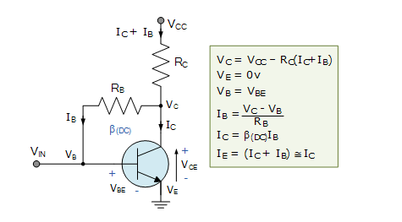
Figure 10 collector feedback circuit
Emitter Feedback Configuration:

This type of transistor biasing configuration, often called self-emitter biasing, uses both emitter and base-collector feedback to stabilize the collector current even further. This is because resistors RB1 and RE as well as the base-emitter junction of the transistor are all effectively connected in series with the supply voltage, VCC. The downside of this emitter feedback configuration is that it reduces the output gain due to the base resistor connection. The collector voltage determines the current flowing through the feedback resistor, RB1 producing what is called “degenerative feedback”. The current flowing from the emitter, IE (which is a combination of IC + IB) causes a voltage drop to appear across RE in such a direction, that it reverse biases the base-emitter junction. So if the emitter current increases, due to an increase in collector current, voltage drop I*RE also increases. Since the polarity of this voltage reverse biases the base-emitter junction, IB automatically decrease. Therefore the emitter current increase less than it would have done had there been no self-biasing resistor. Generally, resistor values are set so that the voltage dropped across the emitter resistor RE is approximately 10% of VCC and the current flowing through resistor RB1 is 10% of the collector current IC. Thus this type of transistor biasing configuration works best at relatively low power supply voltages.
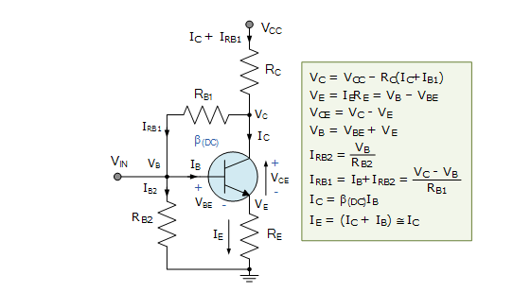
Figure 11 Emitter Feedback Configuration

Activities:
Task 1:
Construct the network of Figure shown below using the 2N3904 transistor. Insert the measured resistance value.
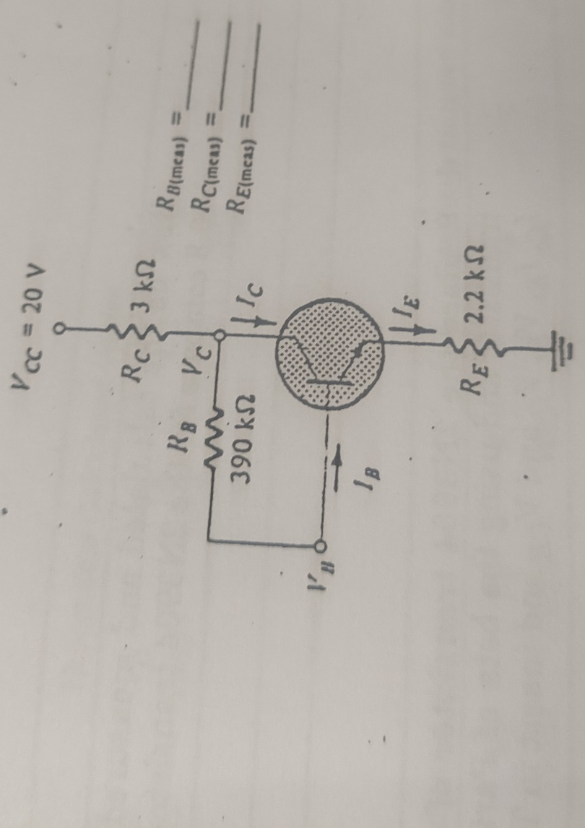

Task: 02
Calculate and Measure values of Ic, Ib and Vce and record the values below:

Ic =
Ib =
Vce =
Beta =

Task: 3
Replace the transistor 2N3904 with 2N4401 transistor and measure the values of Ib, Ic and Vce and record the value given below:
Ic =
Ib =
Vce =
Beta =
Task: 4
Calculate the change in value for both transistor using following formulae:
$$\%ΔB=\frac{\left|B\left(4401\right)-B\left(3904\right)\right|}{\left|B\left(3904\right)\right|}x 100$$
$$\%ΔIC=\frac{\left|Ic\left(4401\right)-Ic\left(3904\right)\right|}{\left|Ic\left(3904\right)\right|} x 100$$
$$\%ΔVce=\frac{\left|Vce\left(4401\right)-Vce\left(3904\right)\right|}{\left|Vce\left(3904\right)\right|}x 100$$
$$\%ΔIB=\frac{\left|IB\left(4401\right)-IB\left(3904\right)\right|}{\left|IB\left(3904\right)\right|}x 100$$

%Δ𝐵 =
%Δ𝐼𝐶 =
%Δ𝑉𝑐𝑒 =
%Δ𝐼𝐵 =

Lab Exercise and Summary
Summary should cover Introduction, Procedure, Data Analysis and Evaluation.

Student’s Signature: ________________ Date: ________________
Cognitive Activity

Q1. Collector-feedback bias: VCC = 12 V, RB = 220 kΩ, RC = 2.2 kΩ, β = 100. Find IB, IC and VCE. (2)
Ans:

Q2. In words, how does the collector-feedback circuit 'fight back' if IC tries to rise (for example when a higher-β transistor is inserted)? (2)
Ans:

Q3. Emitter-bias: VCC = 12 V, RB = 240 kΩ, RE = 1 kΩ, β = 100, VBE = 0.7 V. Find IB and IC. (2)
Ans:

Q4. Explain how the emitter resistor RE makes the Q-point more stable. (2)
Ans:

Q5. Swapping the 2N3904 for the 2N4401 changes IC from 2.1 mA to 2.7 mA while β rises by about 80%. Calculate %change in IC and compare it with %change in β. (2)
Ans:

Obtained Marks | /10

Psychomotor Activity 1 — Experimental Setup

S. No | Criteria | Performance | Description | Marks
1 | Equipment Setup & Safety (4) | Level 4 | Switches ON and configures the DC power supply (current limit set), DMMs and the breadboard with the transistor correctly and independently, and completes the pre-power safety check (supply OFF, no loose wires, instructor approval) without reminders. | 4
1 | Equipment Setup & Safety (4) | Level 3 | Configures the equipment with minor errors or assistance and completes most of the safety checks after one reminder. | 3
1 | Equipment Setup & Safety (4) | Level 2 | Completes the setup with considerable assistance; safety checks are partial and need repeated reminders. | 2
1 | Equipment Setup & Safety (4) | Level 1 | Setup is incomplete and requires substantial assistance; safety checks are skipped or done unsafely. | 1
2 | Circuit/Breadboard Setup (4) | Level 4 | Builds the emitter bias and collector feedback bias circuits as per the schematics with correct RB position, resistor values and pin-out, independently. | 4
2 | Circuit/Breadboard Setup (4) | Level 3 | Circuits are mostly correct with minor errors (e.g. RB connected to the wrong node) corrected after a hint. | 3
2 | Circuit/Breadboard Setup (4) | Level 2 | Circuits are partially built and need considerable assistance. | 2
2 | Circuit/Breadboard Setup (4) | Level 1 | Major errors or omissions in the circuits and substantial assistance needed. | 1
3 | Parameter Setup (2) | Level 2 | Correctly sets VCC, the measured values of RB, RC and RE and the DMM ranges before powering the circuit. | 2
3 | Parameter Setup (2) | Level 1 | Sets most of the required parameters with minor errors (e.g. resistor values not measured). | 1
Total Obtained |  |  |  | /10
If a student is absent:
Criteria | Description | Marks
Absent | Student is absent from the laboratory activity. | 0

Psychomotor Activity 2 — Implementation + Results
S. No | Criteria | Performance | Description | Marks
1 | Implementation (4) | Level 4 | Carries out the emitter bias and collector feedback bias measurements correctly and independently, following the procedure step by step. | 4
1 | Implementation (4) | Level 3 | Carries out the experiment with minor errors or assistance. | 3
1 | Implementation (4) | Level 2 | Partially carries out the experiment and requires considerable assistance. | 2
1 | Implementation (4) | Level 1 | Implementation is largely incomplete and requires substantial assistance. | 1
2 | Execution/Measurement & Safety (2) | Level 2 | Powers ON only after instructor approval, takes VBE, VCE, VRC, VRE and the calculated IB, IC and IE correctly and follows all safety rules (isolate before changes, correct polarity) without reminders. | 2
2 | Execution/Measurement & Safety (2) | Level 1 | Takes the measurements with minor errors or assistance and needs reminders to follow the safety rules. | 1
3 | Results/Output (4) | Level 4 | Obtains correct the measured and calculated Q-points of both circuits and their comparison with the theoretical values and presents them clearly with units and labelled axes/sketches. | 4
3 | Results/Output (4) | Level 3 | Obtains mostly correct results with minor errors in readings or presentation. | 3
3 | Results/Output (4) | Level 2 | Obtains partially correct results with noticeable errors or omissions. | 2
3 | Results/Output (4) | Level 1 | Results are largely incorrect or incomplete and require substantial correction. | 1
Total Obtained |  |  |  | /10

If a student is absent:
Criteria | Description | Marks
Absent | Student is absent from the laboratory activity. | 0
Affective Activity — Lab Report + Viva Voce
S. No | Criteria | Performance | Description | Marks
1 | Lab Report Completeness & Organization (4) | Level 4 | Completes and organizes the report systematically (objective, equipment, circuit diagrams, calculations, data tables and comparison of Q-points, summary), demonstrating responsibility for the assigned laboratory work. | 4
1 | Lab Report Completeness & Organization (4) | Level 3 | Report is complete with minor omissions or organizational issues. | 3
1 | Lab Report Completeness & Organization (4) | Level 2 | Report is partially complete with several omissions. | 2
1 | Lab Report Completeness & Organization (4) | Level 1 | Report contains major omissions and shows limited responsibility toward the assigned work. | 1
2 | Results, Discussion & Conclusion (2) | Level 2 | Presents the results (the measured and calculated Q-points of both circuits and their comparison with the theoretical values) accurately and provides a clear discussion and conclusion based on the completed laboratory work. | 2
2 | Results, Discussion & Conclusion (2) | Level 1 | Presents the required results with minor errors or limited discussion/conclusion. | 1
3 | Viva Voce (4) | Level 4 | Clearly explains how emitter and collector feedback improve Q-point stability compared with fixed bias, the implementation and the results, demonstrating individual responsibility and effective communication. | 4
3 | Viva Voce (4) | Level 3 | Explains most aspects of the assigned work correctly with minor difficulty. | 3
3 | Viva Voce (4) | Level 2 | Explains the basic aspects of the assigned work with some prompting. | 2
3 | Viva Voce (4) | Level 1 | Demonstrates limited involvement or understanding of the assigned work and requires substantial prompting. | 1
Total Obtained |  |  |  | /10
The student has not submitted the report and has not appeared in the Viva Voce.
Criteria | Description | Marks
Lab Report and Results Not Submitted | Student has not submitted the report and results file. | 0
Absent in Viva Voce | Student is absent from the viva voce. | 0

Instructor’s Signature: ________________ Date: ________________

Experiment 121
DC Analysis of Junction Field Effect Transistor (JFET)
Objective:
To understand Junction Field Effect Transistor (JFET) and its output characteristics.
Introduction:
The Junction Field Effect Transistor, or JFET, is a voltage controlled three terminal unipolar semiconductor device available in N-channel and P-channel configurations In the Bipolar Junction Transistor topic, we saw that the output Collector current of the transistor is proportional to input current flowing into the Base terminal of the device, thereby making the bipolar transistor a “CURRENT” operated device (Beta model) as a smaller current can be used to switch a larger load current. The Field Effect Transistor, or simply FET however, uses the voltage that is applied to their input terminal, called the Gate to control the current flowing through them resulting in the output current being proportional to the input voltage. As their operation relies on an electric field (hence the name field effect) generated by the input Gate voltage, this then makes the Field Effect Transistor a “VOLTAGE” operated device.
Figure 1
11.1: N-Channel JFET
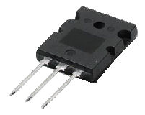
The Field Effect Transistor is a three terminal unipolar semiconductor device that has very similar characteristics to those of their Bipolar Transistor counterparts. For example, high efficiency, instant operation, robust and cheap and can be used in most electronic circuit applications to replace their equivalent bipolar junction transistors (BJT) cousins. The Junction Field Effect Transistor (JFET) has no PN-junctions but instead has a narrow piece of high resistivity semiconductor material forming a “Channel” of either N-type or P-type silicon for the majority carriers to flow through with two ohmic electrical connections at either end commonly called the Drain and the Source respectively. JFET is an essential component for precision level voltage operated controls in analog electronics. We can use JFET as voltage-controlled resistors or as a switch, or even make an amplifier using the JFET. It is also an energy efficient version to replace the BJTs. JFET provides low power consumption and fairly low power dissipations, thus improving the overall efficiency of the circuit. It also provides very high input impedance which is a major advantage over a BJTs.
Figure 11.2: Typical Field Effect Transistor
Basic Types of JFET
There are two basic configurations of junction field effect transistor, the N-channel JFET and the P-channel JFET. The N-channel JFET’s channel is doped with donor impurities meaning that the flow of current through the channel is negative (hence the term N-channel) in the form of electrons.
Likewise, the P-channel JFET’s channel is doped with acceptor impurities meaning that the flow of current through the channel is positive (hence the term P-channel) in the form of holes. N-channel JFET’s have a greater channel conductivity (lower resistance) than their equivalent P-channel types, since electrons have a higher mobility through a conductor compared to holes. This makes the N-channel JFET’s a more efficient conductor compared to their P-channel counterparts. We have said previously that there are two ohmic electrical connections at either end of the channel called the Drain and the Source. But within this channel there is a third electrical connection which is called the Gate terminal and this can also be a P-type or N-type material forming a PN-junction with the main channel. The relationship between the connections of a junction field effect transistor and a bipolar junction transistor are compared below.

Comparison of Connections between a JFET and a BJT
Bipolar Junction Transistor (BJT) | Field Effect Transistor (FET)
Emitter (E) >> Source (S)
Base (B) >> Gate (G)
Collector (C) >> Drain (D)

The symbols and basic construction for both configurations of JFETs are shown below.
The semiconductor “channel” of the Junction Field Effect Transistor is a resistive path through which a voltage V_{DS} causes a current I_{D} to flow and as such the junction field effect transistor can conduct current equally well in either direction. As the channel is resistive in nature, a voltage gradient is thus formed down the length of the channel with this voltage becoming less positive as we go from the Drain terminal to the Source terminal.
The result is that the PN-junction therefore has a high reverse bias at the Drain terminal and a lower reverse bias at the Source terminal. This bias causes a “depletion layer” to be formed within the channel and whose width increases with the bias. The magnitude of the current flowing through the channel between the Drain and the Source terminals is controlled by a voltage applied to the Gate terminal, which is a reverse-biased. In an N-channel JFET this Gate voltage is negative while for a P-channel JFET the Gate voltage is positive. The main difference between the JFET and a BJT device is that when the JFET junction is reverse-biased the Gate current is practically zero, whereas the Base current of the BJT is always some value greater than zero.
Working of JFET
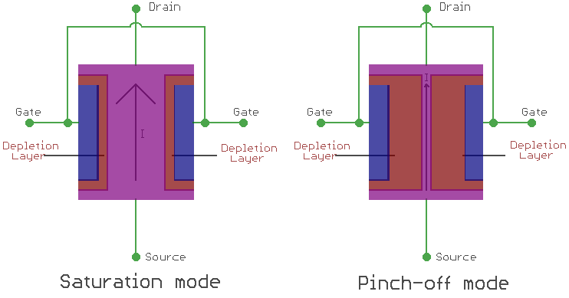
One best example to understand the working of a JFET is to imagine the garden hose pipe. Suppose a garden hose is providing a water flow through it. If we squeeze the hose the water flow will be less and at a certain point if we squeeze it completely there will be zero water flow. JFET works exactly in that way. If we interchange the hose with a JFET and the water flow with a current and then construct the current-carrying channel, we could control the current flow. When there is no voltage across gate and source, the channel becomes a smooth path which is wide open for electrons to flow. But the reverse thing happens when a voltage is applied between gate and source in reverse polarity, that makes the P-N junction reversed biased and makes the channel narrower by increasing the depletion layer and could put the JFET in cut-off or pinch off region.
In the below image we can see the saturation mode and pinch off mode and we will be able to understand the depletion layer became wider and the current flow becomes less.
If we want to switch off a JFET we need to provide a negative gate to source voltage denoted as V_{GS} for an N-type JFET. For a P-type JFET, we need to provide positive V_{GS}.
JFET only works in the depletion mode, whereas MOSFETs have depletion mode and enhancement mode.

Lab Activity:
Task: 1
Construct the network as shown below using 2N4416. Insert the measured value of R.
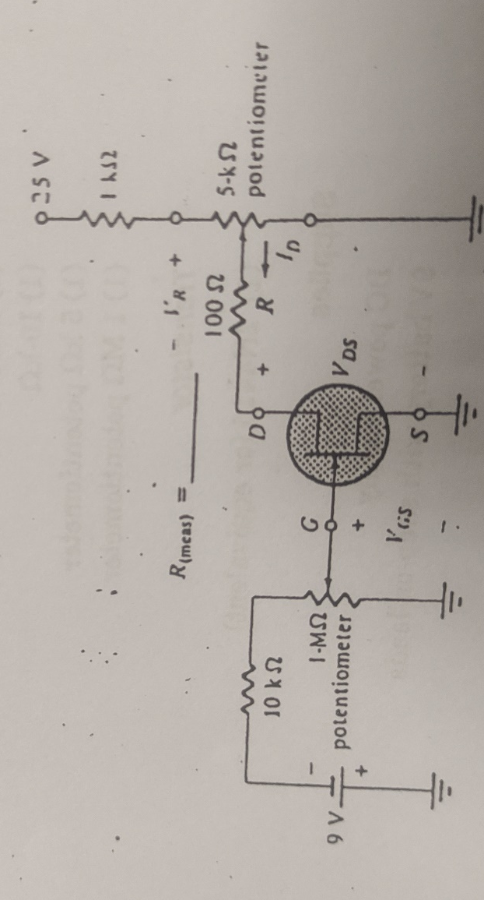
Task: 2
Vary the 1MΩ potentiometer until VGS =0V. Recall that ID=IDSS when VGS = 0V. Set VDS to 8V by varying the 5KΩ potentiometer. Measure the Voltage VR.

VR=
Calculate the saturation Current from IDSS = ID = VR/R using the measured resistance value.
IDSS =

Task: 3
Maintain VDS at about 8V and reduce VGS until VR drops to 1mV at this level ID = VR/R =~0A compared to typical operating levels. Recalls that Vp is the voltage VGS that results in Id = 0mA. Record the pich off voltage below:
Vp =

Task: 4
Using the determined values of IDSS and Vp, find Id for VGS = 5V.
$$ID=IDSS × ({1- \frac{VGS}{Vp})}^{2}$$
$$ID=$$
Task: 5
This part of the experiment will determine the ID versus VDS characteristics for an n channel JFET.
- Using the network use in task 1, vary the two potentiometers until VGS =0V and VDS = 0V. Determine ID from ID= VR/R using the measured value of R and Record in Table 11.1
- Maintain VGS at 0V and increase VDS through 14V (in 1V steps) and record the calculated values of ID.
- Vary the 1MΩ potentiometer until VGS =-1V. Maintaining VGS at this level vary VDS through the level of table and record the readings.
- Plot the

Table 21.1 JFET characteristics table
VGS (V) | 0 | -1 | -2 | -3 | -4 | -5
VDS (V) | ID (mA) | ID (mA) | ID (mA) | ID (mA) | ID (mA) | ID (mA)
0
1
2
3
4
5
6
7
8
9
10
11
12
13

Figure 13 Transfer Characteristics of 2N4416

Lab Exercise and Summary
Summary should cover Introduction, Procedure, Data Analysis and Evaluation.

Student’s Signature: ________________ Date: ________________
Cognitive Activity

Q1. A JFET has IDSS = 10 mA and VP = −4 V. Using ID = IDSS (1 − VGS/VP)^2, find ID at VGS = −2 V. (2)
Ans:

Q2. For the same JFET, what are ID at VGS = 0 V and at VGS = −4 V? What are these two conditions called? (2)
Ans:

Q3. Using the garden-hose analogy from the manual, what does the gate voltage do? Why is the gate current practically zero? (2)
Ans:

Q4. With VGS = 0 V, ID stops rising once VDS exceeds about |VP|. Why, and what is this region called? (2)
Ans:

Q5. Why should the gate-source junction of a JFET never be forward biased beyond about 0.5 V? Compare JFET and BJT control. (2)
Ans:

Obtained Marks | /10

Psychomotor Activity 1 — Experimental Setup

S. No | Criteria | Performance | Description | Marks
1 | Equipment Setup & Safety (4) | Level 4 | Switches ON and configures the two DC supplies (VGS and VDS) and the DMMs correctly and independently, and completes the pre-power safety check (supply OFF, no loose wires, instructor approval) without reminders. | 4
1 | Equipment Setup & Safety (4) | Level 3 | Configures the equipment with minor errors or assistance and completes most of the safety checks after one reminder. | 3
1 | Equipment Setup & Safety (4) | Level 2 | Completes the setup with considerable assistance; safety checks are partial and need repeated reminders. | 2
1 | Equipment Setup & Safety (4) | Level 1 | Setup is incomplete and requires substantial assistance; safety checks are skipped or done unsafely. | 1
2 | Circuit/Breadboard Setup (4) | Level 4 | Builds the JFET characteristic circuit as per the schematic with correct D-G-S connections, supply polarity and meter placement, independently. | 4
2 | Circuit/Breadboard Setup (4) | Level 3 | Circuit is mostly correct with minor errors (e.g. gate supply polarity) corrected after a hint. | 3
2 | Circuit/Breadboard Setup (4) | Level 2 | Circuit is partially built and needs considerable assistance. | 2
2 | Circuit/Breadboard Setup (4) | Level 1 | Major errors (wrong pins, positive gate bias) and substantial assistance needed. | 1
3 | Parameter Setup (2) | Level 2 | Correctly sets the VGS values (0 to -5 V), the VDS sweep range and the DMM ranges for ID before powering the circuit. | 2
3 | Parameter Setup (2) | Level 1 | Sets most of the required parameters with minor errors (e.g. wrong VGS values or meter range). | 1
Total Obtained |  |  |  | /10
If a student is absent:
Criteria | Description | Marks
Absent | Student is absent from the laboratory activity. | 0

Psychomotor Activity 2 — Implementation + Results
S. No | Criteria | Performance | Description | Marks
1 | Implementation (4) | Level 4 | Carries out the ID-VDS output characteristics for each fixed VGS value correctly and independently, following the procedure step by step. | 4
1 | Implementation (4) | Level 3 | Carries out the experiment with minor errors or assistance. | 3
1 | Implementation (4) | Level 2 | Partially carries out the experiment and requires considerable assistance. | 2
1 | Implementation (4) | Level 1 | Implementation is largely incomplete and requires substantial assistance. | 1
2 | Execution/Measurement & Safety (2) | Level 2 | Powers ON only after instructor approval, takes ID for each VDS at every VGS and the pinch-off voltage correctly and follows all safety rules (isolate before changes, correct polarity) without reminders. | 2
2 | Execution/Measurement & Safety (2) | Level 1 | Takes the measurements with minor errors or assistance and needs reminders to follow the safety rules. | 1
3 | Results/Output (4) | Level 4 | Obtains correct the ID versus VDS table and the output characteristic curves with IDSS and the pinch-off voltage marked and presents them clearly with units and labelled axes/sketches. | 4
3 | Results/Output (4) | Level 3 | Obtains mostly correct results with minor errors in readings or presentation. | 3
3 | Results/Output (4) | Level 2 | Obtains partially correct results with noticeable errors or omissions. | 2
3 | Results/Output (4) | Level 1 | Results are largely incorrect or incomplete and require substantial correction. | 1
Total Obtained |  |  |  | /10

If a student is absent:
Criteria | Description | Marks
Absent | Student is absent from the laboratory activity. | 0
Affective Activity — Lab Report + Viva Voce
S. No | Criteria | Performance | Description | Marks
1 | Lab Report Completeness & Organization (4) | Level 4 | Completes and organizes the report systematically (objective, equipment, circuit diagram, the ID-VDS table and the characteristic curves, summary), demonstrating responsibility for the assigned laboratory work. | 4
1 | Lab Report Completeness & Organization (4) | Level 3 | Report is complete with minor omissions or organizational issues. | 3
1 | Lab Report Completeness & Organization (4) | Level 2 | Report is partially complete with several omissions. | 2
1 | Lab Report Completeness & Organization (4) | Level 1 | Report contains major omissions and shows limited responsibility toward the assigned work. | 1
2 | Results, Discussion & Conclusion (2) | Level 2 | Presents the results (the ID versus VDS table and the output characteristic curves with IDSS and the pinch-off voltage marked) accurately and provides a clear discussion and conclusion based on the completed laboratory work. | 2
2 | Results, Discussion & Conclusion (2) | Level 1 | Presents the required results with minor errors or limited discussion/conclusion. | 1
3 | Viva Voce (4) | Level 4 | Clearly explains the difference between JFET and BJT and the meaning of IDSS and pinch-off voltage, the implementation and the results, demonstrating individual responsibility and effective communication. | 4
3 | Viva Voce (4) | Level 3 | Explains most aspects of the assigned work correctly with minor difficulty. | 3
3 | Viva Voce (4) | Level 2 | Explains the basic aspects of the assigned work with some prompting. | 2
3 | Viva Voce (4) | Level 1 | Demonstrates limited involvement or understanding of the assigned work and requires substantial prompting. | 1
Total Obtained |  |  |  | /10
The student has not submitted the report and has not appeared in the Viva Voce.
Criteria | Description | Marks
Lab Report and Results Not Submitted | Student has not submitted the report and results file. | 0
Absent in Viva Voce | Student is absent from the viva voce. | 0

Instructor’s Signature: ________________ Date: ________________

Experiment 142
Determination of Q-Point for Fixed, Self and Voltage Divider Bias Configuration of JFET Circuits
Objective:
To analyze the fixed, self and voltage Divider bias JFET networks
Introduction:
In electronics, Biasing is the setting of initial operating conditions (current and voltage) of an active device in an amplifier. Many electronic devices, such as diodes, transistors and vacuum tubes, whose function is processing time-varying (AC) signals, also require a steady (DC) current or voltage at their terminals to operate correctly. This current or voltage is a bias. The AC signal applied to them is super-positioned on this DC bias current or voltage. For proper working of a transistor, it is essential to apply external voltages of correct polarity across its emitter-base and collector-base junctions. This is transistor biasing. Unlike BJTs, thermal runaway does not occur with FETs. However, the wide differences in maximum and minimum transfer characteristics make ID levels unpredictable with simple fixed-gate bias voltage. To obtain reasonable limits on quiescent drain currents ID and drain-source voltage VDS, source resistor and potential divider bias techniques must be used. With few exceptions, MOSFET bias circuits are similar to those used for JFETs. Various FET biasing circuits in printed circuit board (PCB) design, fabrication and assembly are discussed below.

Biasing of JFET
Different types of techniques are used to bias the JFET in a proper manner. From various techniques, below three are widely used:
- Fixed DC Biasing Technique
- Self-Biasing Technique
- Potential Divider Biasing

Fixed DC Biasing Technique
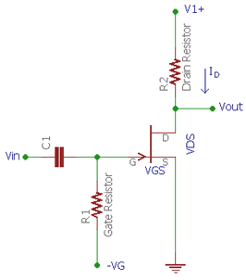
In fixed DC biasing technique of an N channel JFET, the gate of the JFET is connected in such a way that the V_{GS} of the JFET remains negative all the time. As the input impedance of a JFET is very high there are no loading effects observed in the input signal. The current flow through the resistor R1 remains zero.
When we apply an AC signal across the input capacitor C1, the signal appears across the gate. Now, if we calculate the voltage drop across the R1, as per the Ohms law it will be V = I x R or V_{drop} = Gate current x R1. As the current flowing to the gate is 0 the Voltage drop across the gate remains zero. So, by this biasing technique, we can control the JFET drain current by just changing the fixed voltage thus changing the V_{GS}.
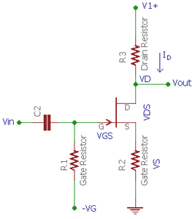
Self-Biasing Technique
In self-biasing technique, a single resistor is added across the source pin. The voltage drop across the source resistor R2 creates the V_{GS} to bias the voltage. In this technique, the gate current is zero again. The source voltage is determined by the same ohms law V = I x R. Therefore, source voltage = Drain current x source resistor. Now, the gate to source voltage can be determined by the differences between gate voltage and source voltage. Since the gate voltage is 0 (as the gate current flow is 0, as per V = IR, gate voltage = Gate current x gate resistor = 0 ) the V_{GS} = 0 – Gate current x Source resistance. Thus there is no external biasing source is needed. The biasing is created by self, using the voltage drop across source resistor.
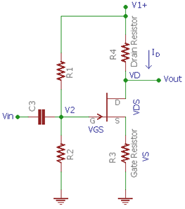
Potential Divider Biasing
In this technique, an additional resistor is used and the circuit is slightly modified from the self-biasing technique, a potential voltage divider using R1 and R2 provide the required DC biasing for the JFET. The voltage drop across the source resistor is needed to be larger than the resistor divider gate voltage. In such a way the V_{GS} remain negative.
Lab Task:
Task: 01
Construct a circuit in fixed Biased Configuration using 2N4416 transistor in which Supply voltage at gate will be -12V Gate Terminal will be connected with 1MΩ potentiometer. RD will be 1KΩ. Find VP and IDSS by varying 1MΩ potentiometer.
Circuit:

Vp =
IDSS =

Task: 02
Calculate and measure ID for specific value of VGS using ID formula.
$$ID=IDSS × ({1- \frac{VGS}{Vp})}^{2}$$

Calculated:
ID =

Measured:
VRD =
ID =

Task: 03
Construct a circuit in Self Biased Configuration using 2N4416 transistor in which Supply voltage at gate will be GND. Gate Terminal will be connected with 10MΩ resistor. RD will be 1KΩ and RS will be 1.2kΩ. Calculate the value of ID using measured value of VGS.
Circuit:

VGS (measured) =
VD (measured) =
VDS (measured) =
ID (calculated) =

Task: 04
Construct a circuit in voltage divider Biased Configuration using 2N4416 transistor in which Supply voltage at gate will be voltage divider configuration of 10kΩ and 3kΩ resistors. VDD for this circuit is 15V. RD will be 1KΩ and RS will be 1.2kΩ. Calculate the value of ID using measured value of VGS.
Circuit:

VGS (measured) =
VD (measured) =
VDS (measured) =
ID (calculated) =

Lab Exercise and Summary
Summary should cover Introduction, Procedure, Data Analysis and Evaluation.

Student’s Signature: ________________ Date: ________________
Cognitive Activity

Q1. Fixed bias: VGG = −2 V, VP = −4 V, IDSS = 8 mA, RD = 1.5 kΩ, VDD = 12 V. Find ID and VDS. (2)
Ans:

Q2. Self-bias: ID = 2 mA flows through RS = 1 kΩ while the gate is tied to ground through RG. What is VGS? Why is VGS negative although VG = 0? (2)
Ans:

Q3. A JFET with larger IDSS is inserted in a self-biased circuit. How does the circuit resist the resulting rise in ID? (2)
Ans:

Q4. Voltage divider bias gives VG = +2 V, RS = 1 kΩ and ID = 3 mA. Find VGS. How can VG be positive and the JFET still be properly reverse biased? (2)
Ans:

Q5. Rank fixed bias, self-bias and voltage divider bias from most to least stable and give a reason. (2)
Ans:

Obtained Marks | /10

Psychomotor Activity 1 — Experimental Setup
S. No | Criteria | Performance | Description | Marks
1 | Equipment Setup & Safety (4) | Level 4 | Switches ON and configures the DC power supplies (VDD, VGG), DMMs and the breadboard with the JFET correctly and independently, and completes the pre-power safety check (supply OFF, no loose wires, instructor approval) without reminders. | 4
1 | Equipment Setup & Safety (4) | Level 3 | Configures the equipment with minor errors or assistance and completes most of the safety checks after one reminder. | 3
1 | Equipment Setup & Safety (4) | Level 2 | Completes the setup with considerable assistance; safety checks are partial and need repeated reminders. | 2
1 | Equipment Setup & Safety (4) | Level 1 | Setup is incomplete and requires substantial assistance; safety checks are skipped or done unsafely. | 1
2 | Circuit/Breadboard Setup (4) | Level 4 | Builds the fixed, self and voltage divider bias JFET circuits as per the schematics with correct pin-out, resistor values and supply polarity, independently. | 4
2 | Circuit/Breadboard Setup (4) | Level 3 | Circuits are mostly correct with minor errors (e.g. RS or RG placed wrongly) corrected after a hint. | 3
2 | Circuit/Breadboard Setup (4) | Level 2 | Circuits are partially built and need considerable assistance. | 2
2 | Circuit/Breadboard Setup (4) | Level 1 | Major errors or omissions in the circuits and substantial assistance needed. | 1
3 | Parameter Setup (2) | Level 2 | Correctly sets VDD, VGG, the measured values of RD, RS, R1 and R2 and the DMM ranges before powering the circuit. | 2
3 | Parameter Setup (2) | Level 1 | Sets most of the required parameters with minor errors (e.g. resistor values not measured). | 1
Total Obtained |  |  |  | /10
If a student is absent:
Criteria | Description | Marks
Absent | Student is absent from the laboratory activity. | 0

Psychomotor Activity 2 — Implementation + Results
S. No | Criteria | Performance | Description | Marks
1 | Implementation (4) | Level 4 | Carries out the fixed, self and voltage divider bias measurements of VGS, VDS and ID correctly and independently, following the procedure step by step. | 4
1 | Implementation (4) | Level 3 | Carries out the experiment with minor errors or assistance. | 3
1 | Implementation (4) | Level 2 | Partially carries out the experiment and requires considerable assistance. | 2
1 | Implementation (4) | Level 1 | Implementation is largely incomplete and requires substantial assistance. | 1
2 | Execution/Measurement & Safety (2) | Level 2 | Powers ON only after instructor approval, takes VGS, VDS, VRD and the calculated ID for each bias circuit correctly and follows all safety rules (isolate before changes, correct polarity) without reminders. | 2
2 | Execution/Measurement & Safety (2) | Level 1 | Takes the measurements with minor errors or assistance and needs reminders to follow the safety rules. | 1
3 | Results/Output (4) | Level 4 | Obtains correct the Q-points (ID, VGS, VDS) of the three circuits with the load line and comparison with theory and presents them clearly with units and labelled axes/sketches. | 4
3 | Results/Output (4) | Level 3 | Obtains mostly correct results with minor errors in readings or presentation. | 3
3 | Results/Output (4) | Level 2 | Obtains partially correct results with noticeable errors or omissions. | 2
3 | Results/Output (4) | Level 1 | Results are largely incorrect or incomplete and require substantial correction. | 1
Total Obtained |  |  |  | /10

If a student is absent:
Criteria | Description | Marks
Absent | Student is absent from the laboratory activity. | 0
Affective Activity — Lab Report + Viva Voce
S. No | Criteria | Performance | Description | Marks
1 | Lab Report Completeness & Organization (4) | Level 4 | Completes and organizes the report systematically (objective, equipment, circuit diagrams, calculations, data tables and the load line/transfer curve, summary), demonstrating responsibility for the assigned laboratory work. | 4
1 | Lab Report Completeness & Organization (4) | Level 3 | Report is complete with minor omissions or organizational issues. | 3
1 | Lab Report Completeness & Organization (4) | Level 2 | Report is partially complete with several omissions. | 2
1 | Lab Report Completeness & Organization (4) | Level 1 | Report contains major omissions and shows limited responsibility toward the assigned work. | 1
2 | Results, Discussion & Conclusion (2) | Level 2 | Presents the results (the Q-points (ID, VGS, VDS) of the three circuits with the load line and comparison with theory) accurately and provides a clear discussion and conclusion based on the completed laboratory work. | 2
2 | Results, Discussion & Conclusion (2) | Level 1 | Presents the required results with minor errors or limited discussion/conclusion. | 1
3 | Viva Voce (4) | Level 4 | Clearly explains how each JFET bias method sets VGS and which method gives the most stable Q-point, the implementation and the results, demonstrating individual responsibility and effective communication. | 4
3 | Viva Voce (4) | Level 3 | Explains most aspects of the assigned work correctly with minor difficulty. | 3
3 | Viva Voce (4) | Level 2 | Explains the basic aspects of the assigned work with some prompting. | 2
3 | Viva Voce (4) | Level 1 | Demonstrates limited involvement or understanding of the assigned work and requires substantial prompting. | 1
Total Obtained |  |  |  | /10
The student has not submitted the report and has not appeared in the Viva Voce.
Criteria | Description | Marks
Lab Report and Results Not Submitted | Student has not submitted the report and results file. | 0
Absent in Viva Voce | Student is absent from the viva voce. | 0

Instructor’s Signature: ________________ Date: ________________

Experiment 13
AC Analysis of Common Emitter and Common Base Amplifier
OBJECTIVE:
- To measure AC and DC voltages in a common-emitter amplifier and common-base amplifier
- To obtain measured values of amplified voltages (Av), input impedance (Zi), and Output impedance (Zo), for load and unloaded operation
Introduction:
Amplification is the process of increasing the strength of signal. Amplifier are the devices that provide amplification without appreciably altering the original signal. BJTs are frequently used as amplifier. It is a current amplifier having three terminals. Base Emitter and collector. The small current into base controls the large current flows collector to Emitter this makes it possible to obtain a large amplification of voltages by taking output from arrestor in parallel with collector.
Common Emitter configuration:
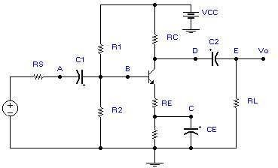
In this arrangement the output taken collector to Emitter and input is applied between base and emitter. Common Emitter amplifier with large voltage divider circuit consist of three capacitor one at input one at output and one act as the coupling capacitor with emitter resistor as shown in Figure 13.1. Input signal is applied at base and output is given at collector terminal.
Figure 13.1 Common Emitter amplifier

Operation of Common Emitter Amplifier

First of all transistor is properly biased. The purpose of biasing is to obtain certain DC collector current and collector voltages. These values are called operating points. The most common biasing circuit is voltage divider. In this method two resistances R1 and R2 are connected across supply voltage Vcc. The voltage drops across R2 forward biased emitter junction this cause base current and hence collector current flows in zero signal condition. Resistance Re provide stabilization.
DC analysis
For amplification, a transistor must be in active region. For common Emitter configuration we have
1. Emitter base junction must be in forward biased
2. Collector base junction must be in reversed biased
DC analysis is done to find out DC parameters like Vc, VCE, VB, VBE, IC, IB and IE. It is also used to find the Q point of transistor.
For DC analysis the coupling capacitor and bypass capacitor are open circuited. To find DC parameters,
To find DC parameters,
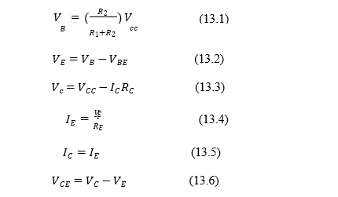
AC analysis
To analyze the AC values first draw AC equivalent circuit. To draw AC equivalent circuit, follow these steps.
1. Capacitor C1 C2 C3 are replaced by effective short circuit
2. The DC source is replaced by a ground
In AC analysis we measure Zin, ZO output voltages and voltage gain.

Zin (Input Impedance)
Resistance connected to input.
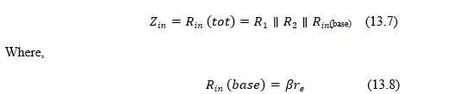
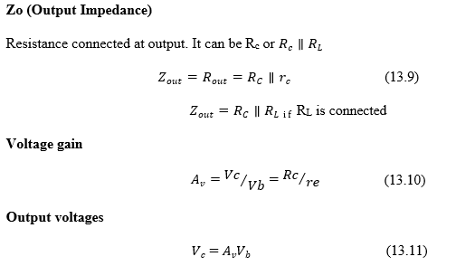

Lab Task:
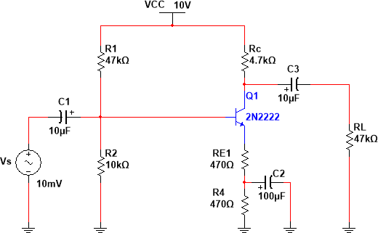
Task: 1
Figure 13.2 Common Emitter Amplifier
Task: 2
Draw AC signal model of Common Emitter Amplifier as shown in fig 13.2.

Task: 3
Compute and measure values of VB, VE, VC, IE using DC analysis
Calculated:
VB=
VE=
VC=
IE=
Calculated re=
Measured:
VB=
VE=
VC=
IE=
re = IE/RE

Task: 4
Compute value of Av, Zi and Zo

Av=

Zi=

Zo=

Task: 5
Apply an AC input signal, Vsig=50mV, rms at f=1kHz. Observe the output waveform on the scope and record the result below and compute Av= Vo/Vsig:

Measured Vo=

Calculated Av=

Task: 6
Calculate and measure DC bias values for the circuit shown below:
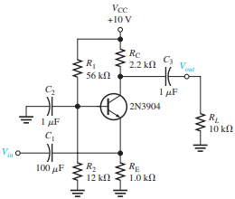
Calculated:
VB=
VE=
VC=
IE=
Calculated re=

Measured:
VB=
VE=
VC=
IE=
re = IE/RE
Task: 7
Draw Ac signal model of circuit given above:

Compute values of Av, Zi and Zo
Av=
Zi=
Zo=

Task: 8
Apply an AC input signal, Vsig=50mV, rms at f=1kHz. Observe the output waveform on the scope and record the result below and compute Av= Vo/Vsig:
Measured Vo=
Calculated Av=
Lab Exercise and Summary
Summary should cover Introduction, Procedure, Data Analysis and Evaluation.

Student’s Signature: ________________ Date: ________________
Cognitive Activity

Q1. The emitter current is IE = 2 mA. Find the small-signal emitter resistance re (use re = 26 mV/IE). (2)
Ans:

Q2. CE amplifier with bypassed RE, RC = 2.2 kΩ, RL = 2.2 kΩ and re = 13 Ω. Estimate Av and the output for Vsig = 50 mV rms. What is the phase relation? (2)
Ans:

Q3. The emitter bypass capacitor CE is accidentally open-circuited (RE = 1 kΩ, RC = 2.2 kΩ, unloaded). What happens to the gain? (2)
Ans:

Q4. Compare the common-base amplifier with the common-emitter amplifier in terms of phase shift and input impedance. (2)
Ans:

Q5. Unloaded output = 4.0 V and output with RL = 2.2 kΩ = 2.0 V. Find Zo. Write the general formula. (2)
Ans:

Obtained Marks | /10

Psychomotor Activity 1 — Experimental Setup

S. No | Criteria | Performance | Description | Marks
1 | Equipment Setup & Safety (4) | Level 4 | Switches ON and configures the DC supply, function generator, CRO (two channels) and DMM correctly and independently, and completes the pre-power safety check (supply OFF, no loose wires, instructor approval) without reminders. | 4
1 | Equipment Setup & Safety (4) | Level 3 | Configures the equipment with minor errors or assistance and completes most of the safety checks after one reminder. | 3
1 | Equipment Setup & Safety (4) | Level 2 | Completes the setup with considerable assistance; safety checks are partial and need repeated reminders. | 2
1 | Equipment Setup & Safety (4) | Level 1 | Setup is incomplete and requires substantial assistance; safety checks are skipped or done unsafely. | 1
2 | Circuit/Breadboard Setup (4) | Level 4 | Builds the common-emitter and common-base amplifiers as per the schematics with correct capacitor polarity, resistor values, transistor pins and common ground, independently. | 4
2 | Circuit/Breadboard Setup (4) | Level 3 | Circuits are mostly correct with minor errors (e.g. capacitor polarity or ground lead) corrected after a hint. | 3
2 | Circuit/Breadboard Setup (4) | Level 2 | Circuits are partially built and need considerable assistance. | 2
2 | Circuit/Breadboard Setup (4) | Level 1 | Major errors (capacitor reversed, missing bias resistor or ground) and substantial assistance needed. | 1
3 | Parameter Setup (2) | Level 2 | Correctly sets VCC, the input signal (frequency and small amplitude), CH1/CH2 VOLTS/DIV, TIME/DIV and coupling before powering the circuit. | 2
3 | Parameter Setup (2) | Level 1 | Sets most of the required parameters with minor errors (e.g. wrong amplitude or channel settings). | 1
Total Obtained |  |  |  | /10

If a student is absent:
Criteria | Description | Marks
Absent | Student is absent from the laboratory activity. | 0

Psychomotor Activity 2 — Implementation + Results
S. No | Criteria | Performance | Description | Marks
1 | Implementation (4) | Level 4 | Carries out the DC bias check and the AC measurements (Vin, Vout, Av, Zi, Zo) with and without load correctly and independently, following the procedure step by step. | 4
1 | Implementation (4) | Level 3 | Carries out the experiment with minor errors or assistance. | 3
1 | Implementation (4) | Level 2 | Partially carries out the experiment and requires considerable assistance. | 2
1 | Implementation (4) | Level 1 | Implementation is largely incomplete and requires substantial assistance. | 1
2 | Execution/Measurement & Safety (2) | Level 2 | Powers ON only after instructor approval, takes DC voltages, input/output waveforms and the load/no-load output voltages correctly and follows all safety rules (isolate before changes, correct polarity) without reminders. | 2
2 | Execution/Measurement & Safety (2) | Level 1 | Takes the measurements with minor errors or assistance and needs reminders to follow the safety rules. | 1
3 | Results/Output (4) | Level 4 | Obtains correct the voltage gain, input and output impedance and the input/output waveforms showing the phase relation and presents them clearly with units and labelled axes/sketches. | 4
3 | Results/Output (4) | Level 3 | Obtains mostly correct results with minor errors in readings or presentation. | 3
3 | Results/Output (4) | Level 2 | Obtains partially correct results with noticeable errors or omissions. | 2
3 | Results/Output (4) | Level 1 | Results are largely incorrect or incomplete and require substantial correction. | 1
Total Obtained |  |  |  | /10

If a student is absent:
Criteria | Description | Marks
Absent | Student is absent from the laboratory activity. | 0
Affective Activity — Lab Report + Viva Voce
S. No | Criteria | Performance | Description | Marks
1 | Lab Report Completeness & Organization (4) | Level 4 | Completes and organizes the report systematically (objective, equipment, circuit diagrams, DC and AC tables, gain/impedance calculations and waveforms, summary), demonstrating responsibility for the assigned laboratory work. | 4
1 | Lab Report Completeness & Organization (4) | Level 3 | Report is complete with minor omissions or organizational issues. | 3
1 | Lab Report Completeness & Organization (4) | Level 2 | Report is partially complete with several omissions. | 2
1 | Lab Report Completeness & Organization (4) | Level 1 | Report contains major omissions and shows limited responsibility toward the assigned work. | 1
2 | Results, Discussion & Conclusion (2) | Level 2 | Presents the results (the voltage gain, input and output impedance and the input/output waveforms showing the phase relation) accurately and provides a clear discussion and conclusion based on the completed laboratory work. | 2
2 | Results, Discussion & Conclusion (2) | Level 1 | Presents the required results with minor errors or limited discussion/conclusion. | 1
3 | Viva Voce (4) | Level 4 | Clearly explains the operation of CE and CB amplifiers, phase relations and the role of the capacitors, the implementation and the results, demonstrating individual responsibility and effective communication. | 4
3 | Viva Voce (4) | Level 3 | Explains most aspects of the assigned work correctly with minor difficulty. | 3
3 | Viva Voce (4) | Level 2 | Explains the basic aspects of the assigned work with some prompting. | 2
3 | Viva Voce (4) | Level 1 | Demonstrates limited involvement or understanding of the assigned work and requires substantial prompting. | 1
Total Obtained |  |  |  | /10
The student has not submitted the report and has not appeared in the Viva Voce.
Criteria | Description | Marks
Lab Report and Results Not Submitted | Student has not submitted the report and results file. | 0
Absent in Viva Voce | Student is absent from the viva voce. | 0

Instructor’s Signature: ________________ Date: ________________

Experiment 14
AC Analysis of Common Source JFET Amplifier
OBJECTIVE:
To implement Junction Field Effect Transistor (JFET) as an amplifier.
Introduction:
Common Source JFET Amplifier uses junction field effect transistors as its main active device offering high input impedance characteristics Transistor amplifier circuits such as the common emitter amplifier are made using Bipolar Transistors, but small signal amplifiers can also be made using Field Effect Transistors. These devices have the advantage over bipolar transistors of having an extremely high input impedance along with a low noise output making them ideal for use in amplifier circuits that have very small input signals.
The design of an amplifier circuit based around a junction field effect transistor or “JFET”, (N-channel FET for this tutorial) or even a metal oxide silicon FET or “MOSFET” is exactly the same principle as that for the bipolar transistor circuit. Firstly, a suitable quiescent point or “Q-point” needs to be found for the correct biasing of the JFET amplifier circuit with single amplifier configurations of Common-source (CS), Common-drain (CD) or Source-follower (SF) and the Common-gate (CG) available for most FET devices. These three JFET amplifier configurations correspond to the common-emitter, emitter-follower and the common-base configurations using bipolar transistors. In this tutorial about FET amplifiers we will look at the popular Common Source JFET Amplifier as this is the most widely used JFET amplifier design. Consider the Common Source JFET Amplifier circuit configuration below.
Common Source JFET Amplifier
The amplifier circuit consists of an N-channel JFET, but the device could also be an equivalent N-channel depletion-mode MOSFET as the circuit diagram would be the same just a change in the FET, connected in a common source configuration. The JFET gate voltage Vg is biased through the potential divider network set up by resistors R1 and R2 and is biased to operate within its saturation region which is equivalent to the active region of the bipolar junction transistor.
Unlike a bipolar transistor circuit, the junction FET takes virtually no input gate current allowing the gate to be treated as an open circuit. Then no input characteristics curves are required. We can compare the JFET to the bipolar junction transistor (BJT) in the following table.

JFET to BJT Comparison
Junction FET | Bipolar Transistor
Gate (G) | Base (B)
Drain (D) | Collector (C)
Source (S) | Emitter (E)
Gate Supply ($V_{G}$) | Base Supply ($V_{B}$)
Drain Supply ($V_{DD}$) | Collector Supply ($V_{CC}$)
Drain Current ($I_{D}$) | Collector Current ($I_{C}$)

Since the N-Channel JFET is a depletion mode device and is normally “ON”, a negative gate voltage with respect to the source is required to modulate or control the drain current. This negative voltage can be provided by biasing from a separate power supply voltage or by a self-biasing arrangement as long as a steady current flows through the JFET even when there is no input signal present and Vg maintains a reverse bias of the gate-source pn junction.
In our simple example, the biasing is provided from a potential divider network allowing the input signal to produce a voltage fall at the gate as well as voltage rise at the gate with a sinusoidal signal. Any suitable pair of resistor values in the correct proportions would produce the correct biasing voltage so the DC gate biasing voltage Vg is given as:
Note that this equation only determines the ratio of the resistors R1 and R2, but in order to take advantage of the very high input impedance of the JFET as well as reducing the power dissipation within the circuit, we need to make these resistor values as high as possible, with values in the order of 1MΩ to 10MΩ being common.
The input signal, (Vin) of the common source JFET amplifier is applied between the Gate terminal and the zero volts rail, (0v). With a constant value of gate voltage Vg applied the JFET operates within its “Ohmic region” acting like a linear resistive device. The drain circuit contains the load resistor, Rd. The output voltage, Vout is developed across this load resistance.
The efficiency of the common source JFET amplifier can be improved by the addition of a resistor, Rs included in the source lead with the same drain current flowing through this resistor. Resistor, Rs is also used to set the JFET amplifiers “Q-point”.
When the JFET is switched fully “ON” a voltage drop equal to Rs*Id is developed across this resistor raising the potential of the source terminal above 0v or ground level. This voltage drop across Rs due to the drain current provides the necessary reverse biasing condition across the gate resistor, R2 effectively generating negative feedback.
So in order to keep the gate-source junction reverse biased, the source voltage, Vs needs to be higher than the gate voltage, Vg. This source voltage is therefore given as:
Then the Drain current, Id is also equal to the Source current, Is as “No Current” enters the Gate terminal and this can be given as:
This potential divider biasing circuit improves the stability of the common source JFET amplifier circuit when being fed from a single DC supply compared to that of a fixed voltage biasing circuit. Both resistors Rs and the source by-pass capacitor, Cs serve basically the same function as the emitter resistor and capacitor in the common emitter bipolar transistor amplifier circuit, namely to provide good stability and prevent a reduction in the loss of the voltage gain. However, the price paid for a stabilized quiescent gate voltage is that more of the supply voltage is dropped across Rs.
The value in farads of the source by-pass capacitor is generally fairly high above 100uF and will be polarized. This gives the capacitor an impedance value much smaller, less than 10% of the transconductance, gm (the transfer coefficient representing gain) value of the device. At high frequencies the by-pass capacitor acts essentially as a short-circuit and the source will be effectively connected directly to ground.
The basic circuit and characteristics of a Common Source JFET Amplifier are very similar to that of the common emitter amplifier. A DC load line is constructed by joining the two points relating to the drain current, Id and the supply voltage, Vdd remembering that when Id = 0: ( Vdd = Vds ) and when Vds = 0: ( Id = Vdd/R_{L} ). The load line is therefore the intersection of the curves at the Q-point as follows.

Common Source JFET Amplifier Characteristics Curves
As with the common emitter bipolar circuit, the DC load line for the common source JFET amplifier produces a straight line equation whose gradient is given as: -1/(Rd + Rs) and that it crosses the vertical Id axis at point A equal to Vdd/(Rd + Rs). The other end of the load line crosses the horizontal axis at point B which is equal to the supply voltage, Vdd.
The actual position of the Q-point on the DC load line is generally positioned at the mid center point of the load line (for class-A operation) and is determined by the mean value of Vg which is biased negatively as the JFET is a depletion-mode device. Like the bipolar common emitter amplifier, the output of the Common Source JFET Amplifier is 180º out of phase with the input signal.
One of the main disadvantages of using Depletion-mode JFET is that they need to be negatively biased. Should this bias fail for any reason the gate-source voltage may rise and become positive causing an increase in drain current resulting in failure of the drain voltage, Vd.
Also, the high channel resistance, Rds(on) of the junction FET, coupled with high quiescent steady state drain current makes these devices run hot so additional heatsink is required. However, most of the problems associated with using JFET’s can be greatly reduced by using enhancement-mode MOSFET devices instead.
MOSFET’s or Metal Oxide Semiconductor FET’s have much higher input impedance’s and low channel resistances compared to the equivalent JFET. Also, the biasing arrangements for MOSFETs are different and unless we bias them positively for N-channel devices and negatively for P-channel devices no drain current will flow, then we have in effect a fail safe transistor.

JFET Amplifier Current and Power Gains
We said previously that the input current, Ig of a common source JFET amplifier is very small because of the extremely high gate impedance, Rg. A common source JFET amplifier therefore has a very good ratio between its input and output impedances and for any amount of output current, I_{OUT} the JFET amplifier will have very high current gain Ai.
Because of this common source JFET amplifiers are extremely valuable as impedance matching circuits or are used as voltage amplifiers. Likewise, because: Power = Voltage x Current, (P = V*I) and output voltages are usually several millivolts or even volts, the power gain, Ap is also very high. In the next tutorial we will look at how the incorrect biasing of the transistor amplifier can cause Distortion to the output signal in the form of amplitude distortion due to clipping and as well as the effect of phase and frequency distortion.

Task:
Construct the circuit given below and plot the input/output waveforms of the amplifier circuit.

VSINE= 25mV peak, frequency= 5K Hz

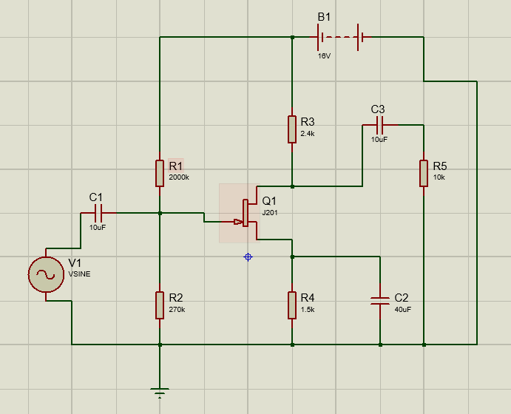

Lab Exercise and Summary
Summary should cover Introduction, Procedure, Data Analysis and Evaluation.

Student’s Signature: ________________ Date: ________________
Cognitive Activity

Q1. A JFET has IDSS = 10 mA and VP = −4 V. Find gm0 = 2 IDSS/|VP| and gm at VGS = −1 V using gm = gm0 (1 − VGS/VP). (2)
Ans:

Q2. With gm = 3.75 mS, RD = 2.2 kΩ and RL = 2.2 kΩ (ignore rd), find the voltage gain. (2)
Ans:

Q3. A BJT biased at IC = 2 mA has gm = IC/26 mV. Compare it with the JFET's 3.75 mS. Which gives more gain, and which loads the source less? (2)
Ans:

Q4. The source bypass capacitor is removed (RS = 1 kΩ, gm = 3.75 mS, RD||RL = 1.1 kΩ). Find the new gain. (2)
Ans:

Q5. You increase the input amplitude until the output shows a flat top near VDD. Which limit has the JFET reached and what would you do? (2)
Ans:

Obtained Marks | /10

Psychomotor Activity 1 — Experimental Setup

S. No | Criteria | Performance | Description | Marks
1 | Equipment Setup & Safety (4) | Level 4 | Switches ON and configures the DC supply, function generator, CRO (two channels) and DMM correctly and independently, and completes the pre-power safety check (supply OFF, no loose wires, instructor approval) without reminders. | 4
1 | Equipment Setup & Safety (4) | Level 3 | Configures the equipment with minor errors or assistance and completes most of the safety checks after one reminder. | 3
1 | Equipment Setup & Safety (4) | Level 2 | Completes the setup with considerable assistance; safety checks are partial and need repeated reminders. | 2
1 | Equipment Setup & Safety (4) | Level 1 | Setup is incomplete and requires substantial assistance; safety checks are skipped or done unsafely. | 1
2 | Circuit/Breadboard Setup (4) | Level 4 | Builds the common-source JFET amplifier as per the schematic with correct D-G-S pins, resistor values, capacitor polarity and common ground, independently. | 4
2 | Circuit/Breadboard Setup (4) | Level 3 | Circuit is mostly correct with minor errors (e.g. capacitor polarity or resistor value) corrected after a hint. | 3
2 | Circuit/Breadboard Setup (4) | Level 2 | Circuit is partially built and needs considerable assistance. | 2
2 | Circuit/Breadboard Setup (4) | Level 1 | Major errors (wrong pins, missing bias network or ground) and substantial assistance needed. | 1
3 | Parameter Setup (2) | Level 2 | Correctly sets VDD, the measured resistor values, the input signal (frequency, small amplitude) and CRO channel settings before powering the circuit. | 2
3 | Parameter Setup (2) | Level 1 | Sets most of the required parameters with minor errors (e.g. wrong signal amplitude or CRO settings). | 1
Total Obtained |  |  |  | /10
If a student is absent:
Criteria | Description | Marks
Absent | Student is absent from the laboratory activity. | 0

Psychomotor Activity 2 — Implementation + Results

S. No | Criteria | Performance | Description | Marks
1 | Implementation (4) | Level 4 | Carries out the DC bias check and the AC measurements of the common-source amplifier correctly and independently, following the procedure step by step. | 4
1 | Implementation (4) | Level 3 | Carries out the experiment with minor errors or assistance. | 3
1 | Implementation (4) | Level 2 | Partially carries out the experiment and requires considerable assistance. | 2
1 | Implementation (4) | Level 1 | Implementation is largely incomplete and requires substantial assistance. | 1
2 | Execution/Measurement & Safety (2) | Level 2 | Powers ON only after instructor approval, takes DC bias voltages, Vin and Vout waveforms and the gain with and without the bypass capacitor correctly and follows all safety rules (isolate before changes, correct polarity) without reminders. | 2
2 | Execution/Measurement & Safety (2) | Level 1 | Takes the measurements with minor errors or assistance and needs reminders to follow the safety rules. | 1
3 | Results/Output (4) | Level 4 | Obtains correct the voltage gain, the 180 degree phase relation and the input/output waveforms without clipping and presents them clearly with units and labelled axes/sketches. | 4
3 | Results/Output (4) | Level 3 | Obtains mostly correct results with minor errors in readings or presentation. | 3
3 | Results/Output (4) | Level 2 | Obtains partially correct results with noticeable errors or omissions. | 2
3 | Results/Output (4) | Level 1 | Results are largely incorrect or incomplete and require substantial correction. | 1
Total Obtained |  |  |  | /10

If a student is absent:
Criteria | Description | Marks
Absent | Student is absent from the laboratory activity. | 0
Affective Activity — Lab Report + Viva Voce
S. No | Criteria | Performance | Description | Marks
1 | Lab Report Completeness & Organization (4) | Level 4 | Completes and organizes the report systematically (objective, equipment, circuit diagram, DC and AC data tables, gain calculations and waveforms, summary), demonstrating responsibility for the assigned laboratory work. | 4
1 | Lab Report Completeness & Organization (4) | Level 3 | Report is complete with minor omissions or organizational issues. | 3
1 | Lab Report Completeness & Organization (4) | Level 2 | Report is partially complete with several omissions. | 2
1 | Lab Report Completeness & Organization (4) | Level 1 | Report contains major omissions and shows limited responsibility toward the assigned work. | 1
2 | Results, Discussion & Conclusion (2) | Level 2 | Presents the results (the voltage gain, the 180 degree phase relation and the input/output waveforms without clipping) accurately and provides a clear discussion and conclusion based on the completed laboratory work. | 2
2 | Results, Discussion & Conclusion (2) | Level 1 | Presents the required results with minor errors or limited discussion/conclusion. | 1
3 | Viva Voce (4) | Level 4 | Clearly explains the working of the CS JFET amplifier, its gain and why its input impedance is high, the implementation and the results, demonstrating individual responsibility and effective communication. | 4
3 | Viva Voce (4) | Level 3 | Explains most aspects of the assigned work correctly with minor difficulty. | 3
3 | Viva Voce (4) | Level 2 | Explains the basic aspects of the assigned work with some prompting. | 2
3 | Viva Voce (4) | Level 1 | Demonstrates limited involvement or understanding of the assigned work and requires substantial prompting. | 1
Total Obtained |  |  |  | /10
The student has not submitted the report and has not appeared in the Viva Voce.
Criteria | Description | Marks
Lab Report and Results Not Submitted | Student has not submitted the report and results file. | 0
Absent in Viva Voce | Student is absent from the viva voce. | 0

Instructor’s Signature: ________________ Date: ________________

